Name: ________________________________



**1.5 Arithmetic and Geometric Sequences**

Introduction to Linear & Exponential Relationships

Warm Up:

Answer each question below and provide an example.

1. What is repeated addition?
2. What is repeated multiplication?

On your own Activity

Knowing this…

1. What is ?
2. What is ?

Fill in the blanks below. Define any vocabulary words that are in **bold**.

**Sequences:** ____________________________________________________________________

The 2 types of sequences that we will learn about in algebra 1 are

___________________________ & ________________________ sequences.

**Arithmetic Sequences:** **Geometric Sequences:**

_________________________________ ___________________________________

_________________________________ ___________________________________

_________________________________ ___________________________________

_________________________________ ___________________________________

Ex. creen Shot 2015-10-05 at 2.43.42 PM.png Ex. creen Shot 2015-10-05 at 2.43.57 PM.png

What is the common difference of this What is the common ratio of this

Arithmetic sequence above? Geometric sequence above?

On your own Activity

Knowing this…

1. Is the sequence  arithmetic or geometric? Then, explain why.
2. Is the sequence  arithmetic or geometric? Then, explain why.

**Write Equations Using Tables**

Geometry examples

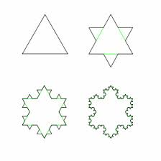*Arithmetic Sequence* *Geometric Sequence*

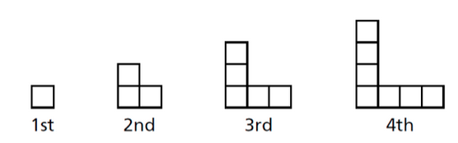

|  |  |  |  |  |
| --- | --- | --- | --- | --- |
| **Term** | **Number of Squares** |  | **Term** | **# of Sides** |
| **1** |  |  | **1** |  |
| **2** |  |  | **2** |  |
| **3** |  |  | **3** |  |
| **4** |  |  | **4** |  |
| **n** |  |  | **n** |  |

**Write Equations Using Tables**

Linear Patterns of Real Life Applications

Gym Membership Example



|  |  |
| --- | --- |
| **# of Months** | **Cost** |
| 1 |  |
| 2 |  |
| 3 |  |
| 4 |  |
| 5 |  |
| m |  |
|  |  |

How long would a year membership cost?

How many months of membership could you get for $400?

(Not in video, I will go over in class)

1. Give at least three real life applications of arithmetic sequences and series mentioned in the video.

**Write Equations Using Tables**

Exponential Patterns of Real Life Applications

Car Depreciation Example

The accepted average car depreciation rate is roughly 15% per year.



|  |  |
| --- | --- |
| **# of years owned** | **Estimated Cost** |
| 0 |  |
| 1 |  |
| 2 |  |
| 3 |  |
| y |  |
|  |  |

How much would the car be worth in 10 years?

1. Give at least three real life applications of geometric sequences and series mentioned in the video.

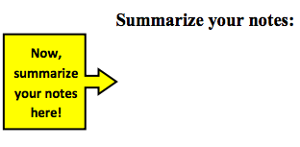

**1.5 Problem Set**

Part 1 – *Vocabulary*

Define the following vocabulary words in your own words. If you are not sure, use your resources.

1. Arithmetic sequence 2) Geometric sequence

Part 2 – *Recognizing Arithmetic vs. Geometric Sequences*

1. Tell whether the sequences are arithmetic, geometric, or neither. Explain why.
2. 
3. 
4. 
5. 
6. 
7. 625, 125, 25, 5, 1, . . .
8. 4, 10, 18, 28, 40, . . .
9. 8, 5, 3, 1, -1 . . .
10. 
11. 
12. 12, 7, 2, 23, 28, . . .
13. 1, 2, 6, 24, 120, . . .
14. 4, 8, 16, 22, 32, . . .

Part 3 – *Real life contexts*

**Write equations for the following arithmetic sequences.**

1. In order to join a dancing club, there is a $30 startup fee and a $4 monthly fee. How much will you have paid in 7 months?
2. In order to join an online learning community, there is a $20 startup fee and a $5 monthly fee. If you have paid $70 for the online learning community, how many months have passed?
3. In order to become a member of the library-all-star-members club, there is a $40 sign-up fee and a $2 monthly fee. Write an equation and use this equation to find the total cost of being an all-star library member for 19 months.
4. Suppose that a bike rents for $4 plus $1.50 per hour. How much would it cost to rent the bike for 8 hours?
5. In order to join a yoga club there is a $100 annual fee and a $5 fee for each class you attend. How many classes will you get for $200?
6. 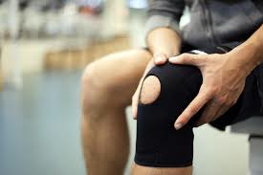After knee surgery, your trainer tells you to return to your jogging program slowly. He suggests jogging for 12 minutes each day for the first week. Each week thereafter, he suggests that you increase that time by 6 minutes per day. How many weeks will it be before you are up to jogging 60 minutes per day?
7. A plumber charges $25 for a service call plus $50 per hour of service. What will be the total cost for 8 hours of work? 10 hours of work?
8. An attorney charges a fixed fee on $250 for an initial meeting and $150 per hour for all hours worked after that. Find the charge for 26 hours of work.
9. Rufus collected 100 pounds of aluminum cans to recycle. He plans to collect an additional 25 pounds each week. How long will it take Rufus to collect 400 pounds of cans?
10. For babysitting, Nicole charges a flat fee of $3, plus $5 per hour. Write an equation for the cost, *C,* after *h* hours of babysitting. What do you think the slope and the y-intercept represent? How much money will she make if she baby-sits 5 hours?

**Write equations for the following geometric sequences.**

1. Deanna received an e-mail asking her to forward it to 10 other people. Assume that no one breaks the chain and that there are no duplicate recipients. How many emails will have been sent during the 8 generation only, Diana’s being the first?
2. There were 1280 actors at the first round of auditions for five parts in a musical production. In each successive round of auditions, one fourth of the actors from the previous round remain. How many actors are left for the 4th round?