Review Sheet

WHAT DO WE KNOW ABOUT RECTANGLES?

What do we know about degree of each angle in a rectangle?

Standard Rectangle | Square
Draw a picture  Label the sides on the picture above.  (Base, height, length, width)  What is the perimeter formula for a rectangle?  What is the area formula for a rectangle? | Draw a picture  Label the sides on the picture above.  (Side)  What is the perimeter formula for a square?  What is the area formula for a square?
What type of units should you use for length, width, or perimeter?

What type of units should you use for area?

WHAT DO WE KNOW ABOUT TRIANGLES?

What is the sum of the interior angles of any triangle?

Scalene Triangles | Isosceles Triangles
Draw a picture  Label the sides on the picture above (Base, height, altitude) | Draw a picture  Label the sides on the picture above  (Base, height, altitude)  What do we know about the angles of an isosceles triangle?  (Explain & Label on picture)
Equilateral Triangles | Right Triangles
Draw a picture  Label the sides on the picture above (Base, height, altitude)  What do we know about the angles of an equilateral triangle?  (Explain & Label on picture) | Draw a picture  Label the sides on the picture above  (Base, height, altitude, a, b, c, legs, hypotenuse)  What do we know about one angle in an equilateral triangle? (Explain & Label on picture)  What do we know about the relationship between the sides in a right triangle?
What is the perimeter formula? What is the area formula?
(Both equations work for all triangles)

For #1-3, do the following:

- Classify the triangle based on the sides (Scalene, Equilateral, or Isosceles)
- Find the area of the triangle.
- Find the perimeter of the triangle.

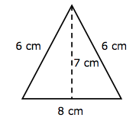
a) __________________________________________

b) __________________________________________

c) __________________________________________

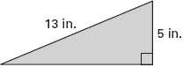

a) __________________________________________

b) __________________________________________

c) __________________________________________

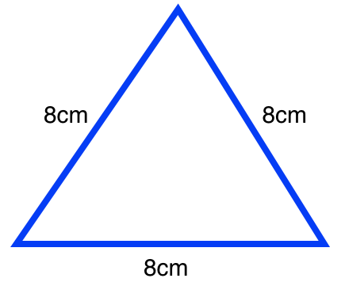
- .

a) __________________________________________

b) __________________________________________

c) __________________________________________

- Assume the lengths given are in yards.

a) Classify the triangle ____________________________
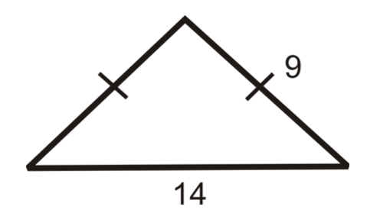
b) Find the perimeter of the triangle.

c) Draw in the height/altitude of the triangle

d) Find the height/attitude of the triangle

e) Find the area of the triangle

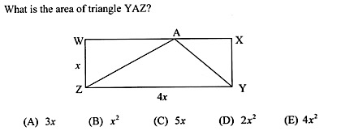
- .

- Find the height of the isosceles triangle below.

___________________________________

- Find the base of a triangle with altitude of 9 meters and an area of 31.5 square meters?

___________________________________

- Solve A&B using the image below.
D

A. How many triangles do you see in the picture?

- Draw each triangle separately and then label each triangle.

- Find the area and perimeter of the triangle below.
(Assume lengths given in the picture are in feet)

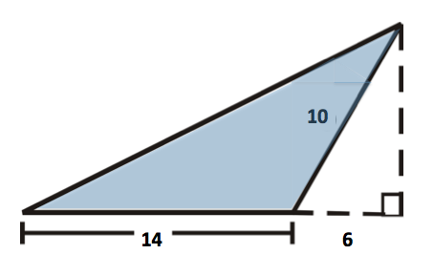
A = ______________________________

P = _____________________________

For problems #8 & #9, find the perimeter and area. (2 points each)
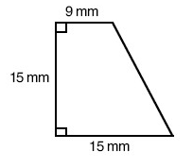
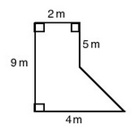
10. 11.

#12 -13 Review from previous chapters and algebra 1:

- Find the diagonal of a square with a perimeter of 32 miles. (Put your answer in radical form)

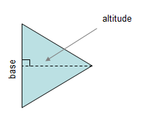
- The area of a triangular sheet of paper is 14 square inches. One side of the triangle is 3 inches longer than the altitude to that side. Find the length of the one side and the length of the altitude to that side.

