Graph Linear Equations (A focus on Algebraic Approach) Name

Previously, we graphed linear equations by plotting several points in a table. But, let’s look forward at the big picture. There are 4 different methods to graph a linear function. Each method has its benefits and we will learn each.

First, let’s take a deeper look at what a linear function is.

- IDENTIFY LINEAR FUNCTIONS
A linear function is:

- A function that can be graphically represented in the coordinate plane by a straight line.
- A linear function is a first-degree polynomial of the form, F(x) = m x + c, where m and c are constants and x is a real variable.

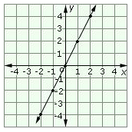

Examples: y = 2x is a linear function (graphed to the right)
y = 3x + 5 is a linear function.
y = $\frac{1}{2}x-4$ is a linear function.

Practice: Identify Linear Functions

Now let’s review the first method…
- REVIEW OF PLOTTING SEVERAL POINTS METHOD

Example 1: $y=-2x+3$

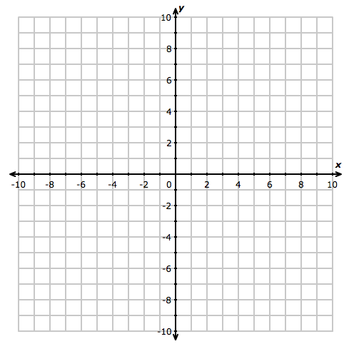

Input  x | Output y

Example 2: $y=\frac{2}{3}x-4$

Input  x | Output y

- FINDING X AND Y INTERCEPTS METHOD

The graphical concept of x- and y-intercepts is pretty simple. The x-intercepts are where the graph crosses the x-axis, and the y-intercepts are where the graph crosses the y-axis.
More specifically,
- a x-intercept is a point in the equation where the y-value is zero, and
- a y-intercept is a point in the equation where the x-value is zero.
Then, algebraically,
- a x-intercept is a point on the graph where y is zero, and
- a y-intercept is a point on the graph where x is zero.

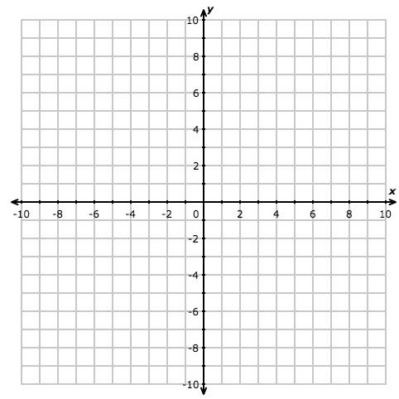

Find the x and y intercepts of each equation below:

Example 1: $y=-2x+3$

Example 2: $y=\frac{2}{3}x-4$

- SLOPE INTERCEPT FORM
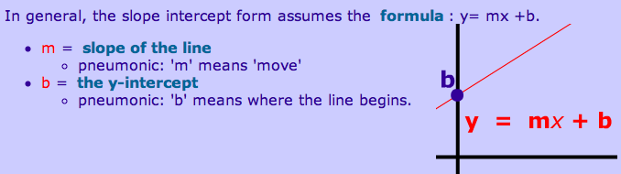

Example 1: $y=-2x+3$ Example 2: $y=\frac{2}{3}x-4$

