**ACTIVITY: ANGLE SUMS IN TRIANGLES**

1. Tape your triangle in the space below. Label the angles in your triangle. Choose one angle and extend the side to form an *exterior angle.*
2. Tear off the angles of the triangle not next to the *exterior angle.* Arrange them to fill in the *exterior angle* drawn. Next to your traced figure, draw a picture of what this looks like. Label your exterior angle and your non-adjacent interior angles.

Make a conjecture about the relationship between the measure of the exterior angle and the measure of the two nonadjacent interior angles.   
  
  
Measure of the exterior angle =

3. Make a Conjecture:

The sum of all the interior angles in a triangle =

**PROOF**

Given: 

Prove:

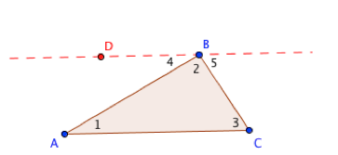

Examples:

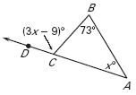**Find an angle measure**

**Example 1:**

Use the diagram at the right to find the measure of DCB.

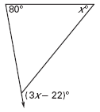**On Your Own 1:**

Find the measure of the exterior angle shown at the right.

**Example 2:**

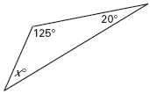Use the diagram at the right to find x.

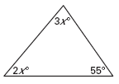**On Your Own 2:**

Use the diagram at the right to find x.

**CLASSIFYING TRIANGLES**

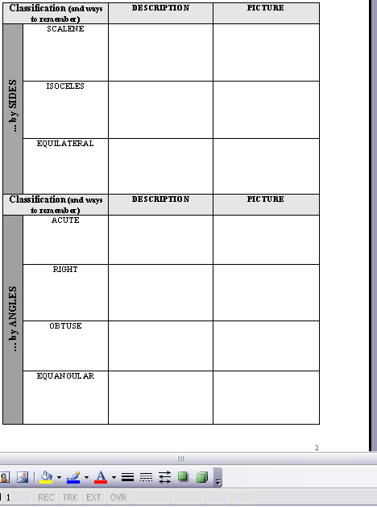

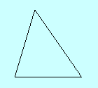

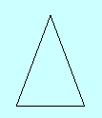

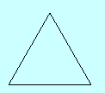



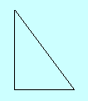

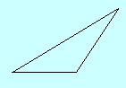



**What is the relationship of sides to the opposite interior angles in a triangle?**

