 Name: ______________________________________________

Macintosh HD:Users:mollyurquhart:Desktop:Screen Shot 2014-02-28 at 12.41.55 PM.png









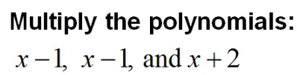



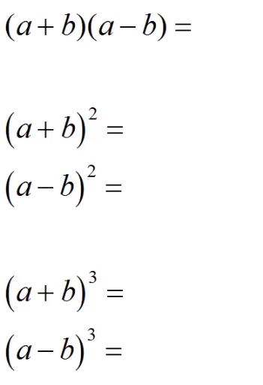

Macintosh HD:Users:mollyurquhart:Desktop:Screen Shot 2014-02-28 at 12.44.21 PM.png

