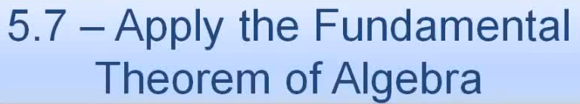 Name: _______________________________

Macintosh HD:Users:mollyurquhart:Desktop:Screen Shot 2014-02-28 at 1.13.28 PM.png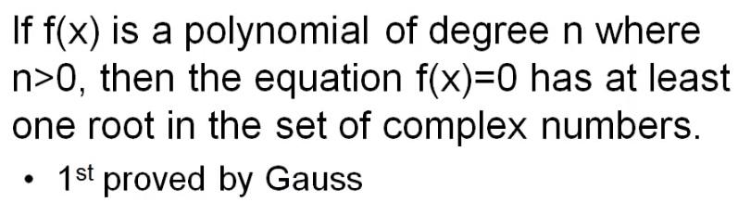



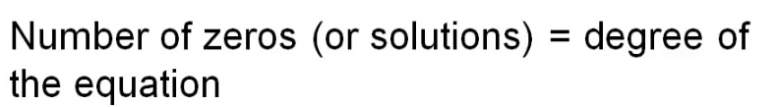

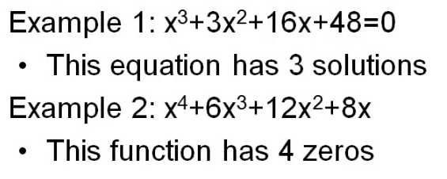

Macintosh HD:Users:mollyurquhart:Desktop:Screen Shot 2014-02-28 at 1.14.17 PM.png



Macintosh HD:Users:mollyurquhart:Desktop:Screen Shot 2014-02-28 at 1.14.32 PM.png

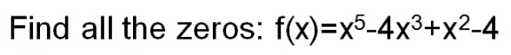











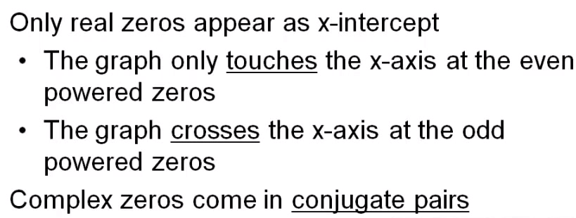



Macintosh HD:Users:mollyurquhart:Desktop:Screen Shot 2014-02-28 at 1.16.17 PM.png

Macintosh HD:Users:mollyurquhart:Desktop:Screen Shot 2014-02-28 at 1.16.33 PM.png

