 Name: _______________________________





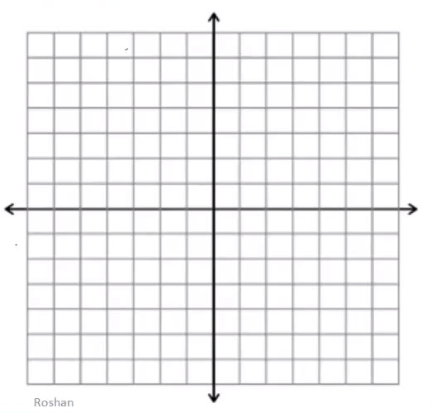

Macintosh HD:Users:mollyurquhart:Desktop:Screen Shot 2014-02-28 at 1.25.38 PM.png

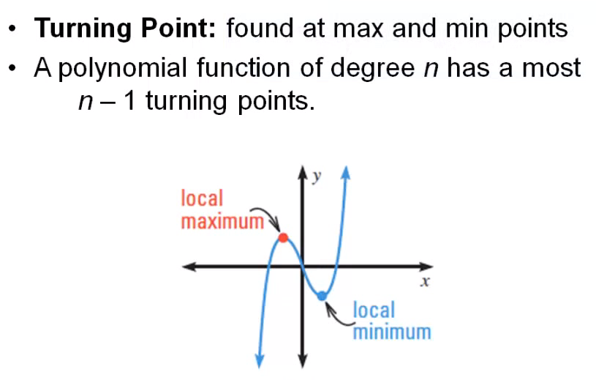

Macintosh HD:Users:mollyurquhart:Desktop:Screen Shot 2014-02-28 at 1.26.03 PM.png

