**Order of Operations**

Simplifying Numerical Expressions Name: __________________________________________

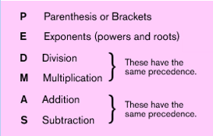

[EXAMPLES](http://teachers.henrico.k12.va.us/math/ms/c20708/01NumberSense/1_3/702Notes1.mov)

1. **Does the expression contain grouping symbols? What are they?**

|  |  |  |  |  |  |
| --- | --- | --- | --- | --- | --- |
| 1. | ______________________________ | 2. | ______________________________ | 3. | _______________________________ |
| 4. | _____________________________________ | 5. | ____________________________________ | 6. | ____________________________________ |
|  |  |  |  |  |  |

1. **Find the value of each expression.**

|  |  |  |  |  |  |
| --- | --- | --- | --- | --- | --- |
| 1. |  | 2. |  | 3. |  |
| 4. |  | 5. |  | 6. |  |
| 7. |  | 8. |  | 9. |  |

1. **Simplify each numerical expression.**

|  |  |  |  |  |  |
| --- | --- | --- | --- | --- | --- |
| 1. |  | 2. |  | 3. |  |
| 4. |  | 5. |  | 6. |  |
| 7. |  | 8. |  | 9. |  |
| 10. |  | 11. |  | 12. |  |
| 13. |  | 14. |  | 15. |  |
| 16. |  | 17. |  | 18. |  |