**Adding Like Terms** Name: _________________________________

**& Solving Equations**

|  |  |  |  |
| --- | --- | --- | --- |
|  | | **1.** |  |
|  | | **2.** |  |
| **Algebra**  **REVIEW** |  | | |
|  | | | |

|  |  |  |  |  |  |  |  |
| --- | --- | --- | --- | --- | --- | --- | --- |
| **3.** |  | **4.** |  | **5.** |  | **6.** |  |
| **7.** |  | **8.** |  | **9.** |  | **10.** |  |

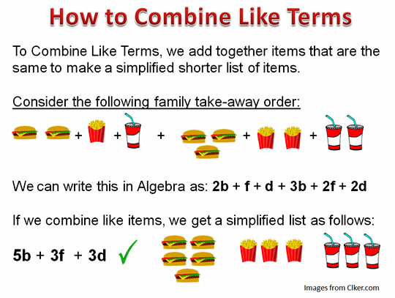

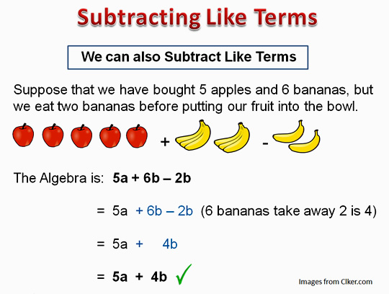

One your Own: **Simplify the following expressions.**

A)  Hint: Think of apples and bananas

B)  Hint: Think of burgers, fries, and drinks

**Directions:** Simplify.

The directions tell you to simplify. Scan the following problems. What do you think it means to simplify in this case? _____________________________________________________

|  |  |  |
| --- | --- | --- |
| **1) 3x + 2x =** | **2) –2y – –4y =** | **3) x + –4x + –3x =** |
| **4) y + y + –10x =** | **5) 5x2 – 7x2 + 4x2 =** | **6) –4xy + 12xy =** |
| **7) –5 + –3x + –10x =** | **8) 4y2 – 12y2 + 7 – 2 =** | **9) 5y + –9y – 5x + –3x – 2y =** |
| **10) –7 + 3x – 4 + 2x =** | **11) 14 + –6x2 – 3x2 – 8 =** | **12) 2a + 3a – 7a – 5a =** |
| **13) x + –x =** | **14) 3y – –10y + 7y =** | **15) –7 – 4b – –3b + –6b + 5 =** |
| **16) x + x =** | **17) –x2 –x2 =** | **18) xy + –xy =** |

**Summary:** What are the rules for combining like terms?

**Extra Practice**

|  |  |  |
| --- | --- | --- |
| **1) 5x + x =** | **2) –6y – 3y =** | **3) 9x – 4x + –5x =** |
| **4) 4y + 5x =** | **5) –5x2 + –10x2 + 2x2 =** | **6) 4xy + –9xy – 3xy =** |
| **7) –5x + –4x + –7x =** | **8) –4y2 + 11y2 + 7y – 2y =** | **9) –5y + –9y + 5x + –10x + 14y =** |
| **10) –7 + x – 5 + 2x =** | **11) –4 – –6x2 – 3x2 + 8 =** | **12) 2a + –3a – 7a – –5a =** |
| **13) x + –2x =** | **14) 13y + –10y – 7y =** | **15) 7 – 4b – 7b + –6b – 5 =** |
| **16) x + x =** | **17) –x2 –x2 =** | **18) y –y =** |
| **19) 2y2 + –10y2 – 5x2 –10x2 =** | **20) 5y + –8y – 12 y + 4y + –7y =** | **21) –6 – 4c – 3 – –2c + –6c + 15 =** |

|  |  |
| --- | --- |
| **Geometry**  **Review**  (Part 1) | **Area and Perimeter of a Rectangle**  **Example Formula .** |
|  |  |

Find the area and perimeter of each rectangle below

**1. 2.**

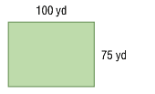 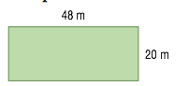

**3.** Write an algebraic expression for the perimeter and the area of the rectangle below.

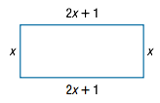

|  |  |
| --- | --- |
| **Geometry**  **Review**  (Part 2) | **Area and Perimeter of a Triangle**  **Example Formula .**    **5**  **5** |

Perimeter = 16 units

Area = 12 square units

For #1-3, find the area and perimeter of each triangle below.

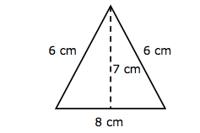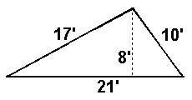

**1. 2.**

**3. 4.** Write an algebraic expression for the perimeter and

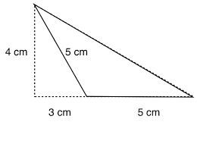the area of the rectangle below.

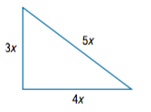

**8.9**

**Multi-Step Equations**

**Goal:** Isolate the variable.

You need to use a combination of the follow properties:

|  |  |
| --- | --- |
| **Property** | **Example** |
| *Distributive Property* |  |
| *Combining Like Terms* |  |
| *Addition Property of Equality*  *Subtraction Property of Equality* |  |
| *Multiplication Property of Equality*  *Division Property of Equality* |  |

Solve each equation. Check by plugging in your answer.

|  |  |  |  |
| --- | --- | --- | --- |
| 1. |  | 2. |  |
| 3. |  | 4. |  |
| 5. |  | 6. |  |
| 7. |  | 8. |  |
| 9. |  | 10. |  |
| 11. |  | 12. |  |
| 13. |  | 14. |  |
|  |  |  |  |
| 15. |  | 16. |  |
| 17. |  | 18. |  |
| 19. |  | 20. |  |
|  |  |  |  |
| 21. |  | 22. |  |
| 23. |  | 24. |  |
| 25. |  | 26. |  |
| 27. |  | 28. |  |
| 29. |  | 30. |  |
| 31. |  | 32. |  |

33. Find 3 consecutive odd integers whose sum is -3.

Let n = the least odd integers.

Then n+2 = the greater odd integer

Then n+4 = the greatest odd integer



34. Find two consecutive odd integers whose sum is 128.



35. Find 3 consecutive even integers whose sum is 90.



36. Sally is eight years older than John. John is fourteen years older than Karen. If the sum of all three ages is 90, how old is each person?



**Equations with Variables on Both Sides**

**Goal:** Isolate the variable.

You need to use a combination of the follow properties:

|  |  |
| --- | --- |
| **Property** | **Example** |
| *Distributive Property* |  |
| *Combining Like Terms* |  |
| *Addition Property of Equality*  *Subtraction Property of Equality* |  |
| *Multiplication Property of Equality*  *Division Property of Equality* |  |

**Multi-Step Equations & Variables on Both Sides**

Notes:

Solve each equation.

|  |  |  |  |  |  |
| --- | --- | --- | --- | --- | --- |
| 1. |  | 2. |  | 3. |  |
| 4. |  | 5. |  | 6. |  |
| 7. |  | 8. |  | 9. |  |
| 10. |  | 11. |  | 12. |  |
| 13. |  | 14. |  | 15. |  |

|  |  |  |  |
| --- | --- | --- | --- |
| 1. |  | 2. |  |
| 3. |  | 4. |  |
| 5. |  | 6. |  |
| 7. |  | 8. |  |
| 9. |  | 10. |  |
| 11. |  | 12. |  |
|  |  |  |  |
| 13. |  | 14. |  |
|  |  |  |  |
| 15. |  | 16. |  |