Assessment Name: ______________

Area and Perimeter

- Consider a room that is 16' by 20'.

  - How many square feet of carpeting do you need to purchase? (Include Units)

  - How many feet of trim do you need? (Include Units)

- A farmer is trying to build a pen for his pigs if he wants the dimensions of the pen to be 9 yards in length and 11 yards in width.

  - How much fencing in yards does he need to purchase? (Include Units)

  - What amount of space does this allow his pigs to roam inside the pen? (Include Units)

3. Find the area and perimeter.

4. Find the area and perimeter.

Extra credit:

A. Without using a grid find the area and perimeter of the figure below.

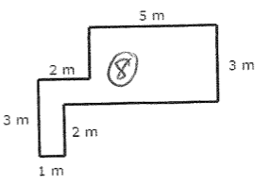

B. The label on a tin of paint states that it contains enough paint to cover 10m². Sarah needs to paint a wall that measures 9 meters by 5 meters. How many cans of paint does she need?
- 3 cans of paint
- 5 cans of paint
- 28 cans of paint
- 45 cans of paint

