Area and Perimeter Name: ____________________
Quiz

Directions:

- Take your time
- This is not an open notes quiz, calculators are allowed.
- Make sure to show work (Show calculations and draw diagrams)

Vocabulary:

- What is perimeter? What types of units is perimeter measured in?

- What is area? What types of units is area measured in?

Straight Forward Problems:
Find the perimeter and area of a rectangle. Explain how you found your answers.
- Find the perimeter of the rectangle. (Make sure to include units)

- Find the area of the rectangle. (Make sure to include units)

Find the perimeter and area of a rectangle with width 6cm and length 10 cm.

- Find the perimeter of the rectangle. (Make sure to include units)

- Find the area of the rectangle. (Make sure to include units)

Story Problems:
Lisa’s bedroom is 6 meters long and 4 meters wide. How much carpet will Lisa need to cover the floor of her bedroom? (Draw a picture)

- Does this scenario consider perimeter or area? _________________
- How much carpet should she purchase? (Include units) ________________

Amy and Jimmy wanted to build a backyard pen for their new puppy. After measuring the yard, they drew a picture showing the shape and size of the pen.
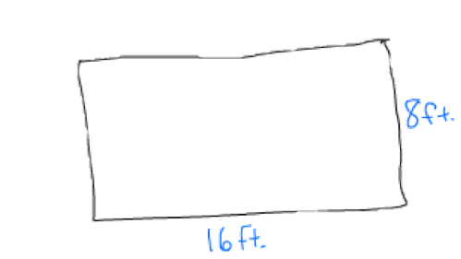
- Jimmy asked, “How will we know how much fencing to buy at the store?” Amy, who was older and wiser than her younger brother, replied,
______________________________________________________________________
______________________________________________________________________
_____________________________________________________________________ .
- Does this scenario consider perimeter or area? _________________
- How much fencing should they purchase? (Include units) ________________

Multiple Choice:
- The label on a tin of paint states that it contains enough paint to cover 10m². Sarah needs to paint a wall that measures 3 meters by 4 meters. How many cans of pain does she need?
- 1 can of paint
- 2 cans of paint
- 12 cans of paint
- 14 cans of paint

- What is the area of a rectangular desktop that has a length of 5 feet and a width of 2 feet?
- 7 feet
- 14 feet
- 10 feet
- 14 square feet
- 10 square feet

14.
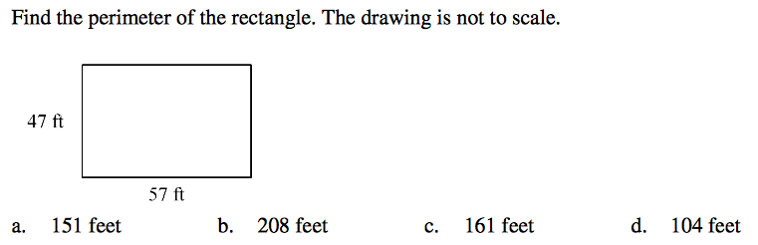
15.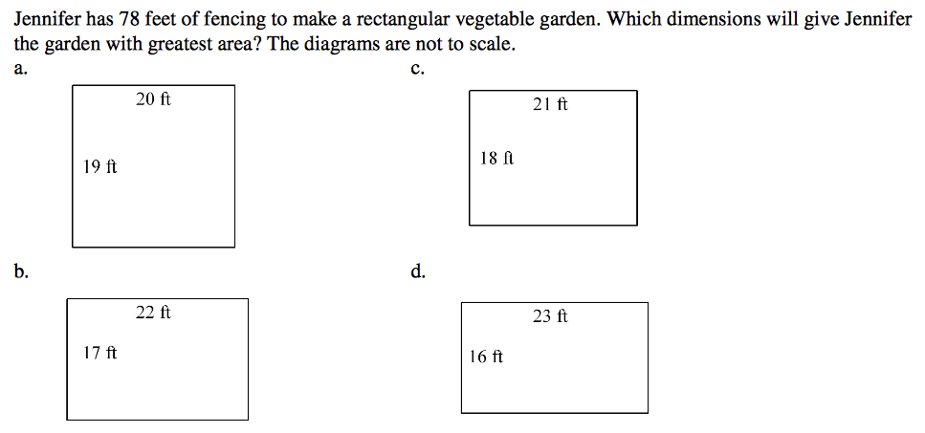

Extra Credit
Does a rectangular garden with a length of 6 feet and a width of 4 feet, or a square garden with side length 5 feet, have the greater area? Which requires more fencing? Explain.

