Composition of Functions Name: _______________________

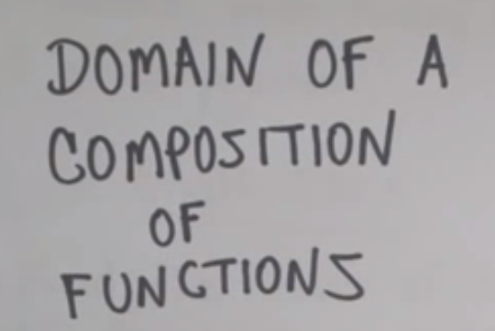

Compositions of functions

Ex 1

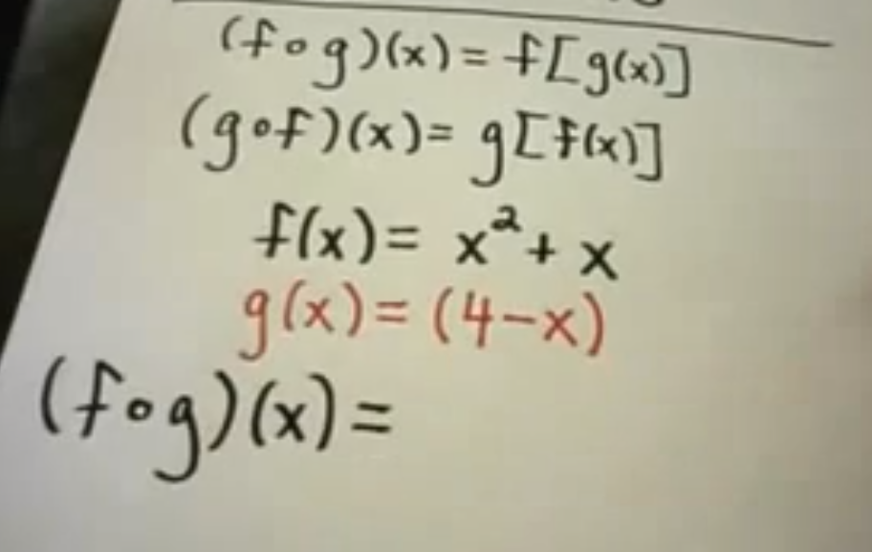

Ex. 2

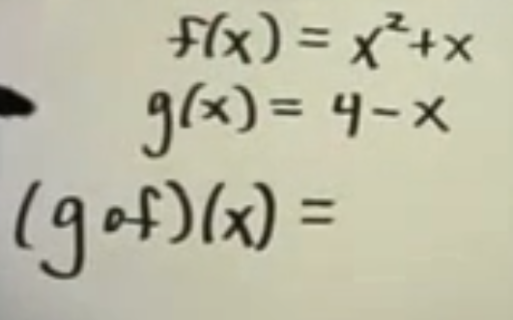

Domain of a Function

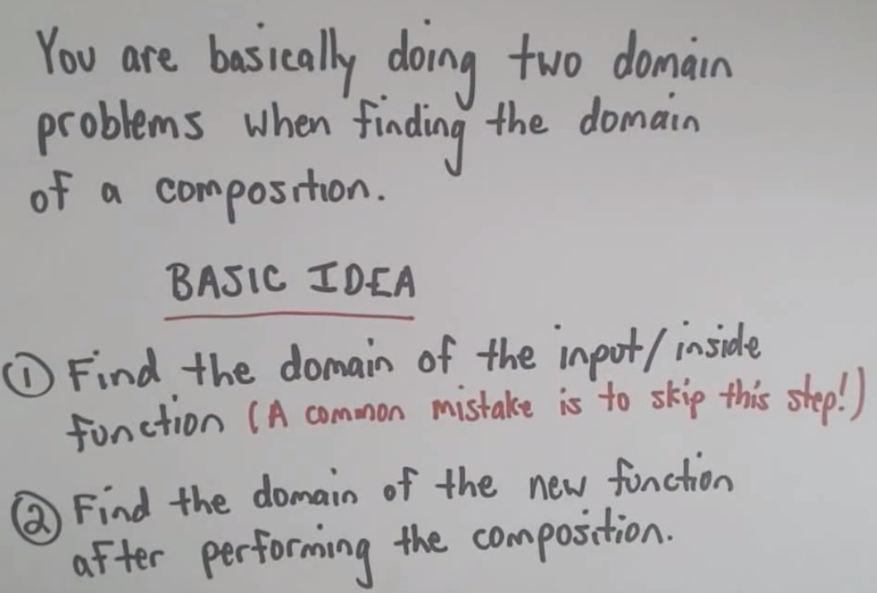

Ex. 3

