Congruent Triangle W.S. Name: ______________________________________

Problem # | Explaination.
1.
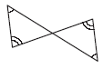
2.
3.
4.
5.

6.
7.
8.
9.
10.

11.
12.
13.
14.
15.

16. Explain how you can prove that the indicated triangles are congruent using the given postulate or theorem.
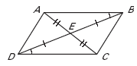
a.

b.

c.

