Explaining Area Formulas: Name: __________________________________
Notes:

- What is the area of any rectangle? Explain how the formula is derived.

- What is the area of any square? Explain how the formula is derived.

- What is the area of any triangle? Explain how the formula is derived.

- What is the area of any parallelogram? Explain how the formula is derived.

- What is the area of any kite? (Works for Rhombus too) Explain how the formula is derived.

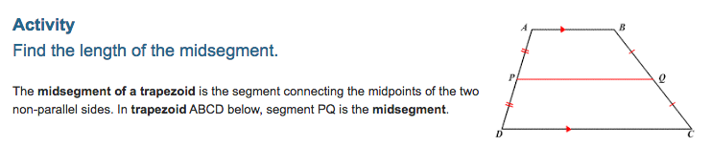
Directions: Follow the steps below.
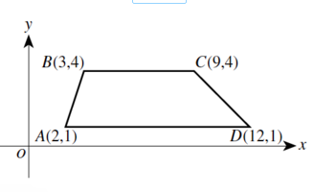
Step 1 - Label the midpoint of the segment AB point P and find the coordinates of point P.
Step 2 - Label the midpoint of the segment CD point S and find the coordinates of point S.
Step 3 - Find the length of the segment BC
Step 4 - Find the length of the segment AD
Step 5 - Find the length of the segment PS (i.e. the midsegment)
Step 6 - Is there a relationship that you see?

- What is the area of any trapezoid? Explain how the formula is derived.

Extra Space for any extra notes:

_________________________________________________________________________________________________________________

_________________________________________________________________________________________________________________

_________________________________________________________________________________________________________________

_________________________________________________________________________________________________________________

PRACTICE PROBLEMS

1. 2. 3.

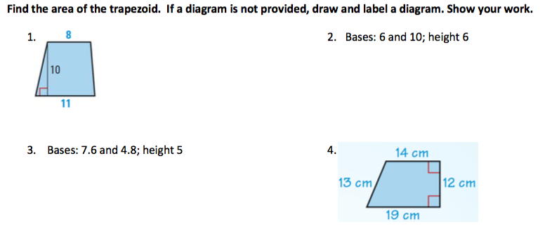
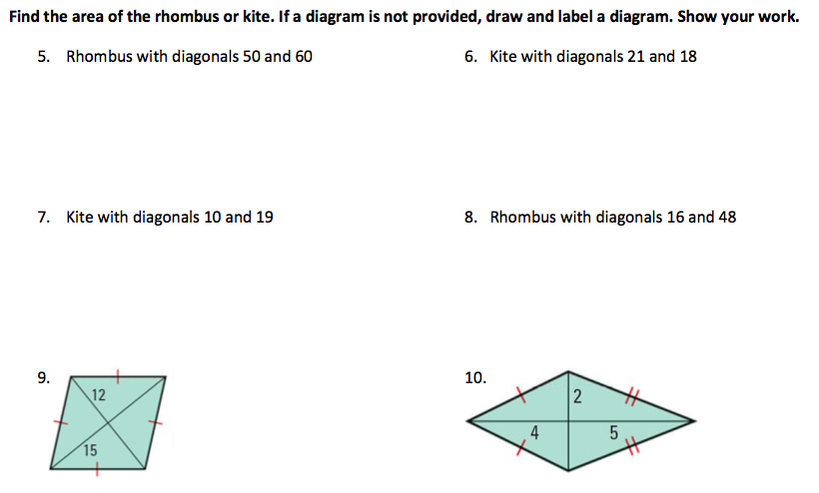

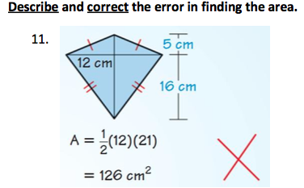
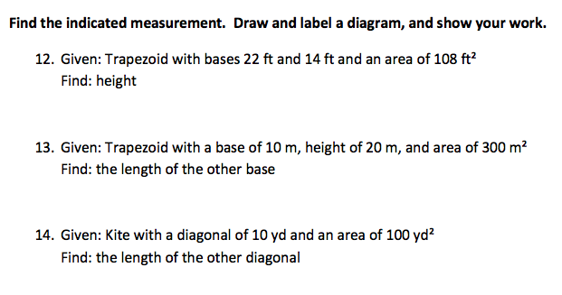

15. Multiple Choice: Lengths are shown in inches on the drawing of the rectangle below. What is the shaded area, in square inches?
A. 18
B. 24
C. 57
D. 78
E. 96

16.

23. Find the area of the rhombus below.

24. Find the area of the quadrilateral ABCD given A(2, -2), B(6,4), C(-1,5), and D(-5, 2).

25. Find the area of the rhombus below.

Find the area of each trapezoid below.
26. 27.

28. Find the area and perimeter of the regular pentagon below.

