Discount Assignment Name: _______________________________________

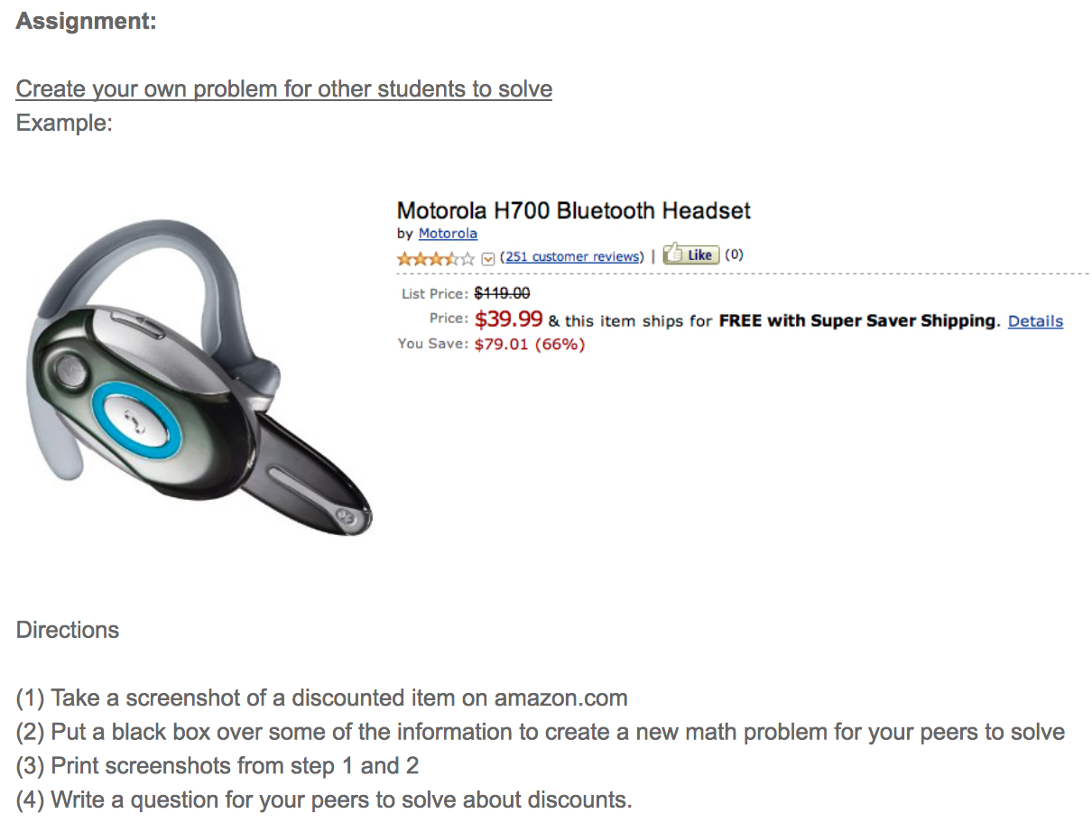
(5) Repeat this process 3 times.

Problem #1

Paste image here. Then cover up the percentage off and the price with the black text boxes below.

What discount related question could you ask about the picture?

Problem #2

Paste image here. Then cover up the amount you save and the price with the black text boxes below.

What discount related question could you ask about the picture?
Problem #3

Paste image here. Then cover up the amount you save and the percentage off with the black text boxes below.

What discount related question could you ask about the picture?

Problem #4

Paste image here. Then cover up the list price and the amount you save with the black text boxes below.

What discount related question could you ask about the picture?

When you finish:

* Email your four word problems to Ms. Urquhart (murquhart@aimhighschool.com),
* Print your problems,
* And finally, make an answer key to your four problems (show your work).

