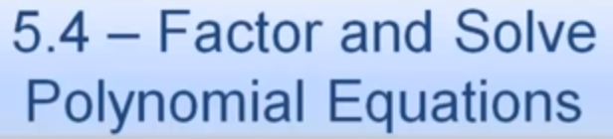 Name: __________________________________________



