Function Operations Name: ________________________

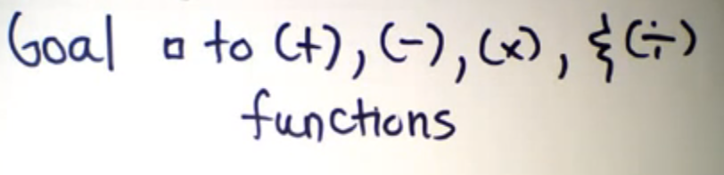

Ex. 1 Adding Functions Ex. 2 Subtracting Functions

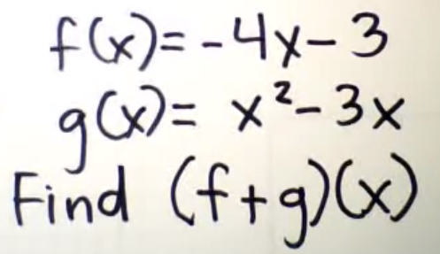 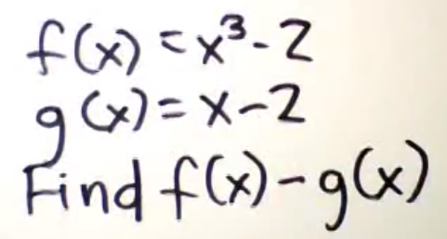

Ex. 3

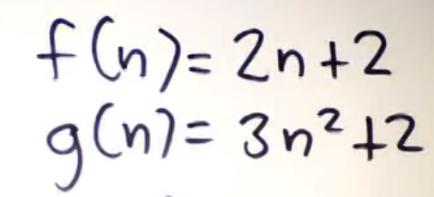

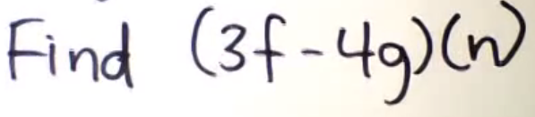

Ex. 4 Multiply Functions Ex. 5

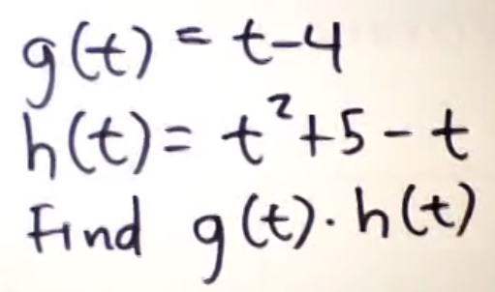 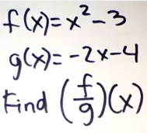

Ex. 6 Ex. 7

