 Name: ______________________________________

**Vocabulary**

A rational function has the form

* Where p(x) and q(x) are polynomials and

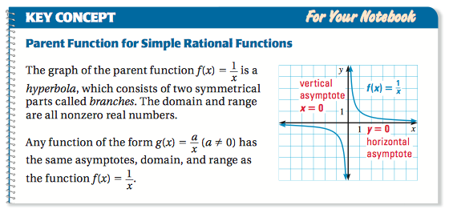

|  |  |  |  |  |  |  |  |  |  |  |  |
| --- | --- | --- | --- | --- | --- | --- | --- | --- | --- | --- | --- |
| x | -4 | -2 | -1 | -½ | -¼ | 0 | ¼ | ½ | 1 | 2 | 4 |
| f(x) |  |  |  |  |  |  |  |  |  |  |  |

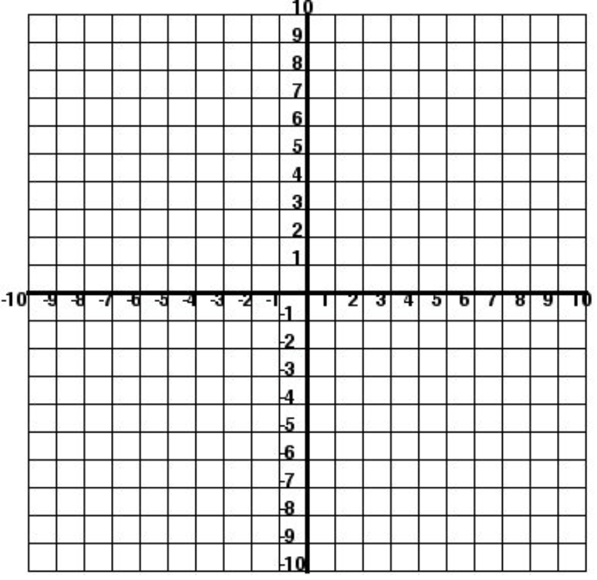Macintosh HD:Users:mollyurquhart:Desktop:Screen Shot 2014-03-03 at 10.20.47 AM.png Macintosh HD:Users:mollyurquhart:Desktop:Screen Shot 2014-03-03 at 10.21.02 AM.png



**Key Concept**

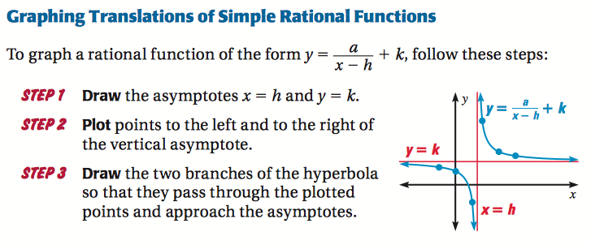

Macintosh HD:Users:mollyurquhart:Desktop:Screen Shot 2014-03-03 at 10.21.58 AM.png **Macintosh HD:Users:mollyurquhart:Desktop:Screen Shot 2014-03-03 at 10.36.41 AM.png**

H.A.

V.A.

**Key Concept**

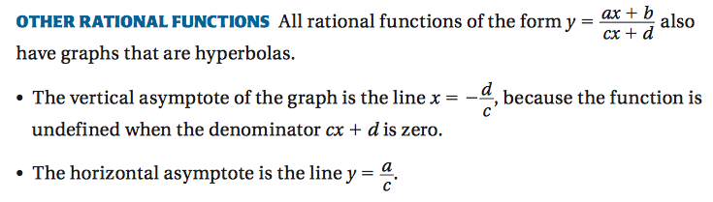

H.A.

V.A.

 Macintosh HD:Users:mollyurquhart:Desktop:Screen Shot 2014-03-03 at 10.39.46 AM.png

H.A.

V.A.

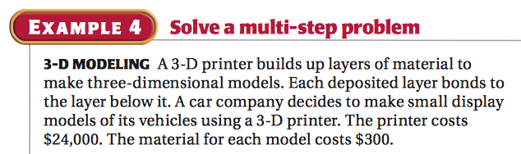 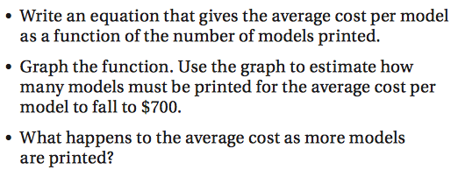

H.A.

V.A.