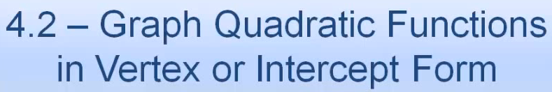 Name: ________________________________________



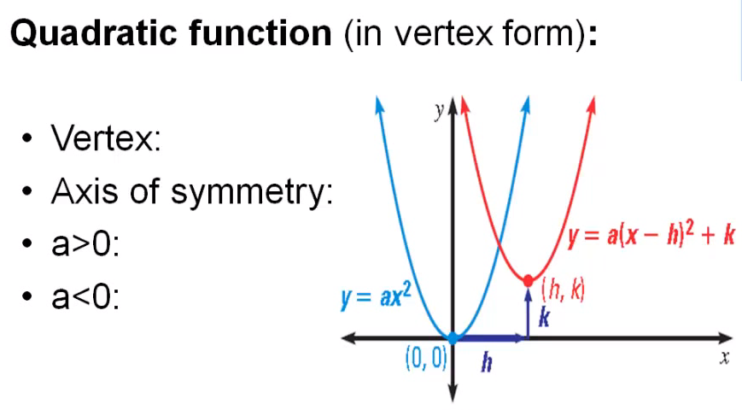

Macintosh HD:Users:mollyurquhart:Desktop:Screen Shot 2014-03-07 at 8.06.31 AM.png

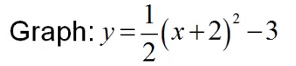

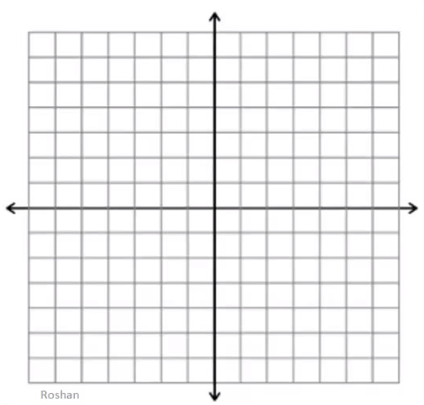

Macintosh HD:Users:mollyurquhart:Desktop:Screen Shot 2014-03-07 at 8.07.10 AM.png

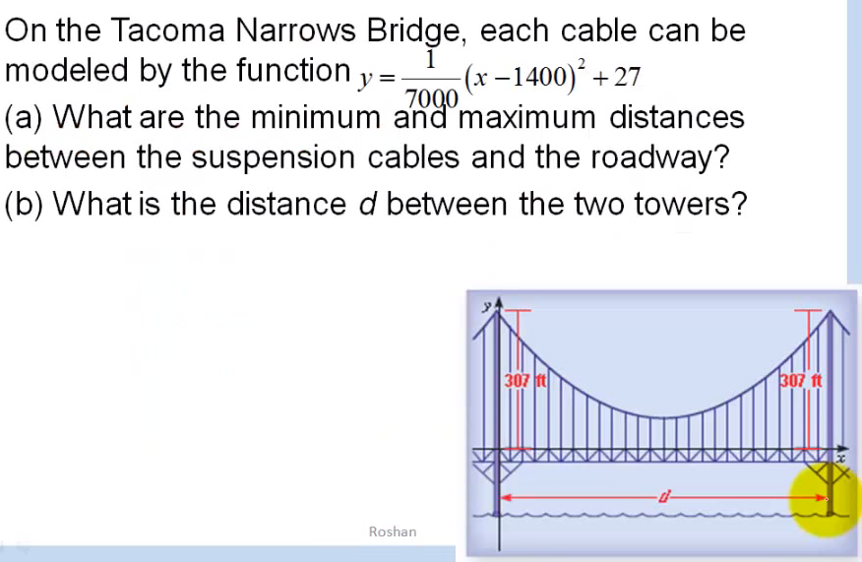



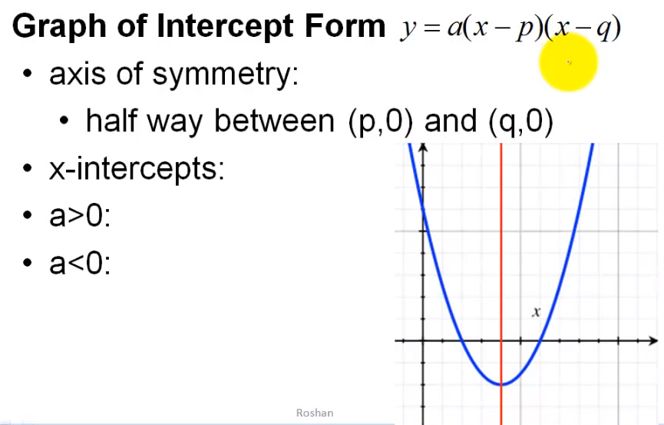



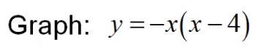

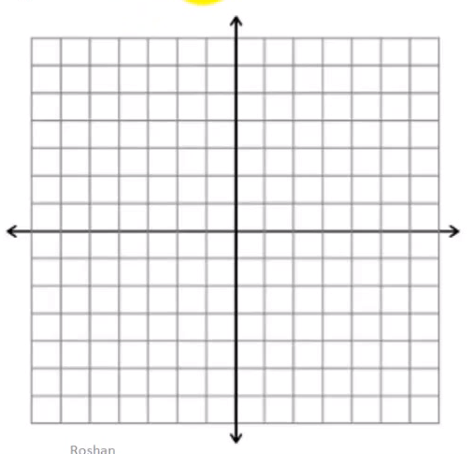



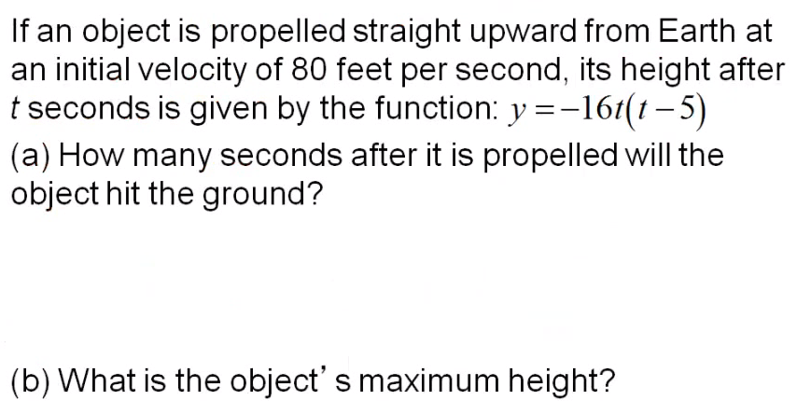

Macintosh HD:Users:mollyurquhart:Desktop:Screen Shot 2014-03-07 at 8.09.07 AM.png

Macintosh HD:Users:mollyurquhart:Desktop:Screen Shot 2014-03-07 at 8.09.14 AM.png

Macintosh HD:Users:mollyurquhart:Desktop:Screen Shot 2014-03-07 at 8.09.30 AM.png

