Name: ________________________________________

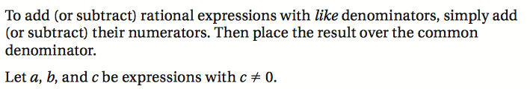

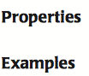

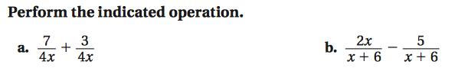

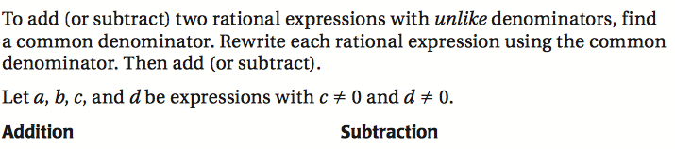

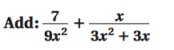

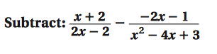

A complex fraction is

