Guided Notes Name: _______________________

**Proportion**

A proportion is an _________________ that states that two ratios are____________, such as 

Proportions are useful for solving for an unknown.

For instance, 

**This simple approach may not be sufficient when working with more complex proportions.  
You need a rule:**

**Cross Multiplication**

**Example:**

** 🡪  **

**Proportional**

2 shapes are proportional if they look the___________________, even if they are different sizes.

Circle the images that are proportional. Cross out the ones that are not.

   

Find the height of the tree to the left.

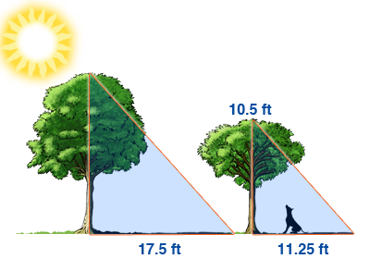

**More advanced proportion problems.** Solve each problem below using cross multiplication.



