 Name: _______________________________________

Macintosh HD:Users:mollyurquhart:Desktop:Screen Shot 2014-03-06 at 10.01.50 AM.png



Macintosh HD:Users:mollyurquhart:Desktop:Screen Shot 2014-03-06 at 10.02.47 AM.png

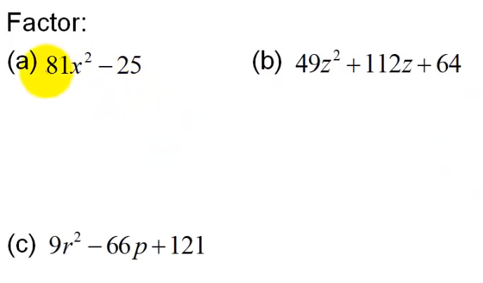

Macintosh HD:Users:mollyurquhart:Desktop:Screen Shot 2014-03-06 at 10.03.12 AM.png

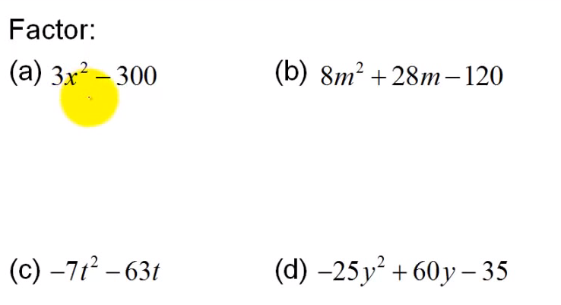



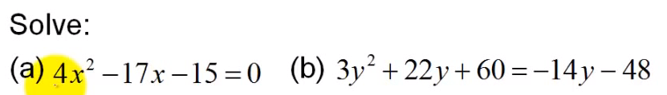

Macintosh HD:Users:mollyurquhart:Desktop:Screen Shot 2014-03-06 at 10.03.59 AM.png

