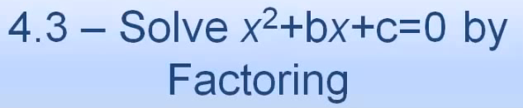 Name: ______________________________________

Macintosh HD:Users:mollyurquhart:Desktop:Screen Shot 2014-03-17 at 9.58.35 PM.png



Macintosh HD:Users:mollyurquhart:Desktop:Screen Shot 2014-03-17 at 9.58.56 PM.png

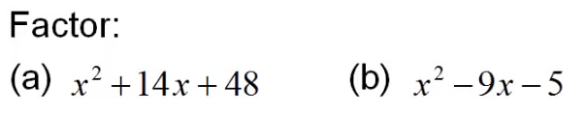



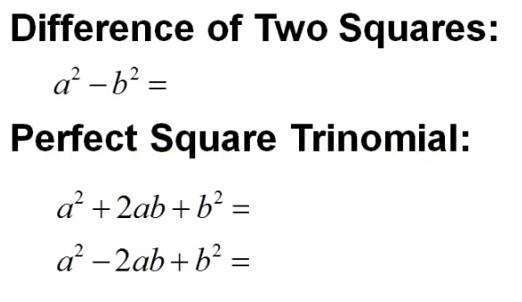

Macintosh HD:Users:mollyurquhart:Desktop:Screen Shot 2014-03-17 at 9.59.50 PM.png

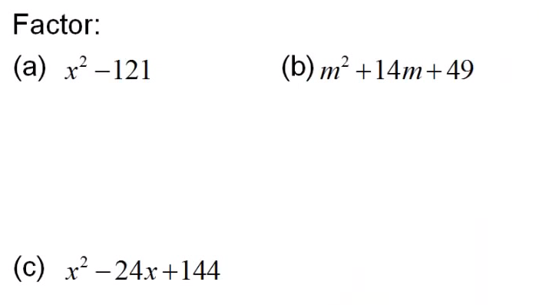



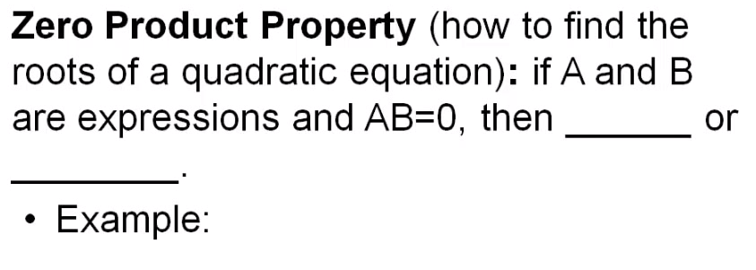



Macintosh HD:Users:mollyurquhart:Desktop:Screen Shot 2014-03-17 at 10.00.39 PM.png

Macintosh HD:Users:mollyurquhart:Desktop:Screen Shot 2014-03-17 at 10.01.05 PM.png

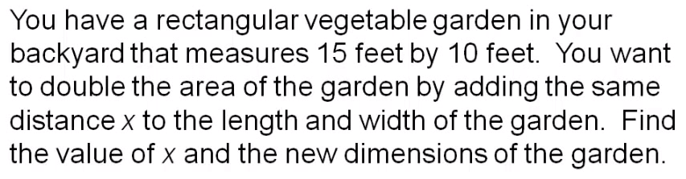

Macintosh HD:Users:mollyurquhart:Desktop:Screen Shot 2014-03-17 at 10.01.40 PM.png

