Name: ______________________________________
Vocabulary

What is a rational function?

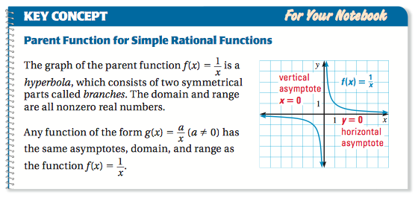

Plug in point into table for the equation of the parent function.

x | -4 | -2 | -1 | -½ | -¼ | 0 | ¼ | ½ | 1 | 2 | 4
f(x)

What is an asymptote?

What is a vertical asymptote?

What is a horizontal asymptote?

Go to www.desmos.com and launch calculator. Then, in your book, turn to page 561 and complete problems #3-10. Do evens first with Desmos and odds without Desmos.

3.

4.

5.

6.

7.

8.

9.

10.

25.

How does the variable “a” affect the parent function of a rational function?

Key Concept
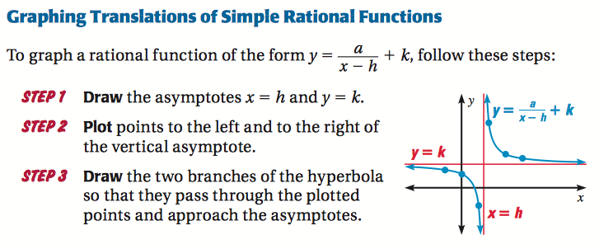

Go to www.desmos.com and launch calculator. Then, in your book, turn to page 561 and complete problems #11-23. Do evens first with Desmos and odds without Desmos.

11.

12.

13.

14.

15.

16.

17.

18.

26.

How do the variables “a,” “h,” and “k” affect the parent function of a rational function?

Key Concept

Ask Ms. U how to find x-intercept(s) and vertical asymptotes.

In your book, turn to page 561 and complete problems #27,29,30,31, and 33.

27.

29.

30.

31.

33.

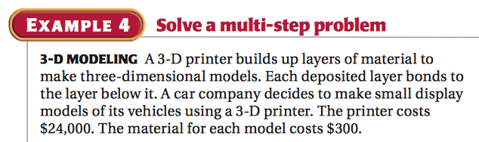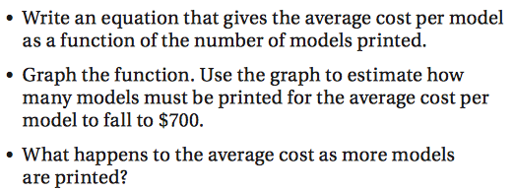

On a separate sheet of paper do problems #37 and 38

