 Name: ________________________________________



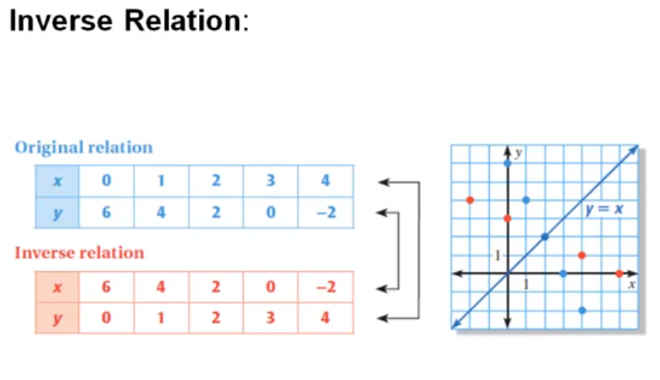



 (Graph the original function y and its inverse function)

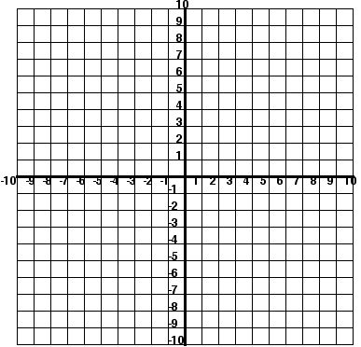



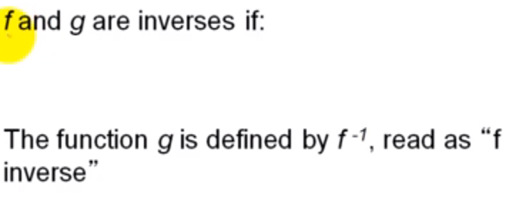







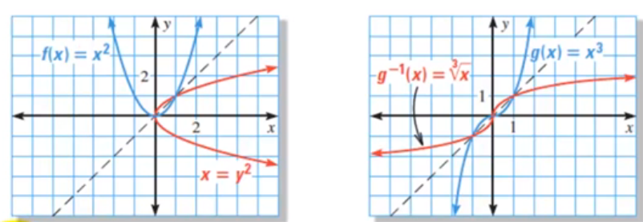



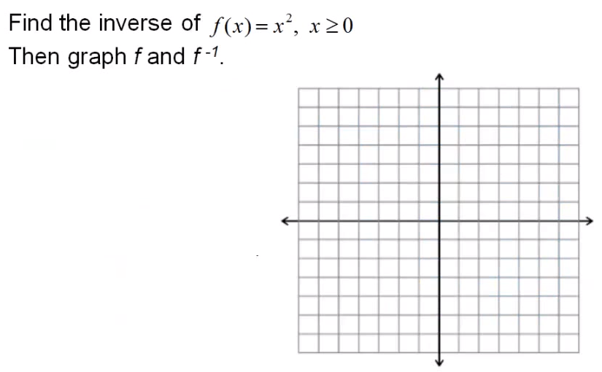



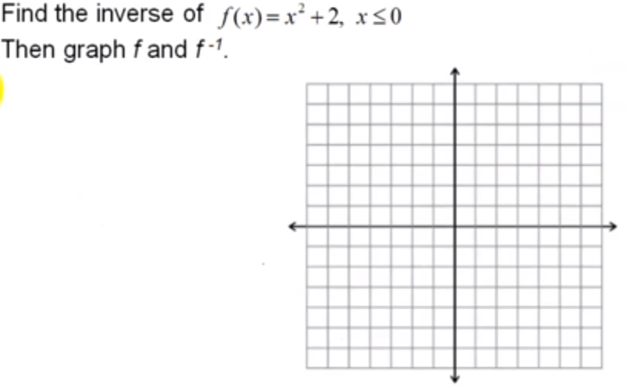



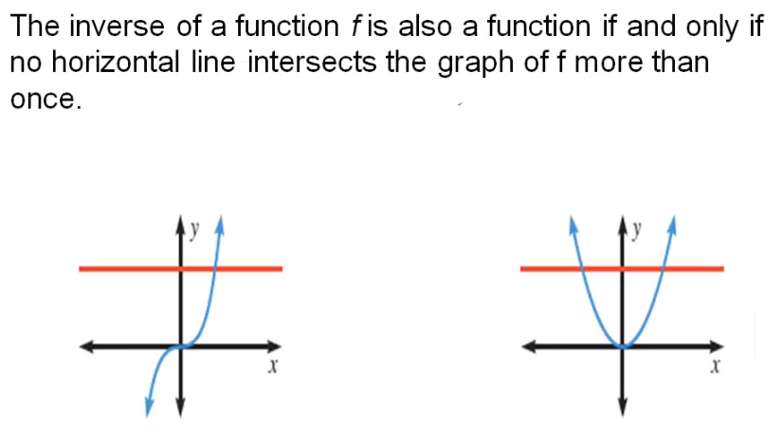







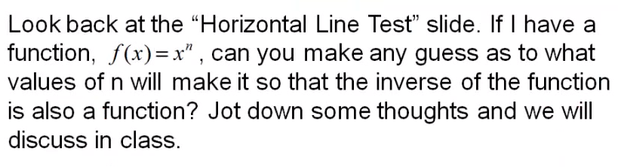

Book Problems: p. 442 #3-11 odd,15-43odd,48