**4.2 Isosceles Triangles**  Name: _________________________________

Recall that an isosceles triangle has at least two congruent sides. The congruent sides are called the legs. The vertex angle is the angle formed by the legs. The side opposite the vertex angle is called the base, and the base angles are the two angles that have the base as a side.



The Isosceles Triangle Theorem The Isosceles Triangle Theorem (Converse)

Example 1 Example 2 Example 3

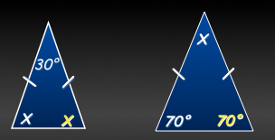  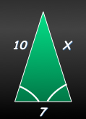

Example 4

