Real life story from Ms. Urquhart

“On my first day as the new math teacher in Pittsburgh PA, all the teachers went out to eat after school. I was excited to meet everyone and establish my new identity at this new workplace. When I sat down at the restaurant to eat, I quickly realized my wallet was missing! I then excused myself and checked my car still no luck. Luckily, I did find a twenty-dollar bill in my car. So, I went back in. Not wanting my new staff to get a bad first impression of me, I didn’t tell anyone and would look for the wallet later after dinner. Therefore the real life math question arose, I needed to figure out what I could spend on food before tax and tip without going over $20.”

Imagine you were in my scenario, how could you find out much you could spend before tax and tip?

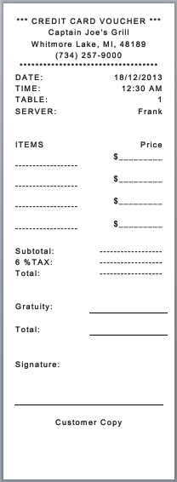
- Using the online Captain Joe’s Grill menu, order at least a meal, a side, a salad, a beverage, and a dessert. Then calculate the total cost including the Michigan sales tax and an appropriate tip for good waiter or waitress. Make you to write down the items you choose from the menu.

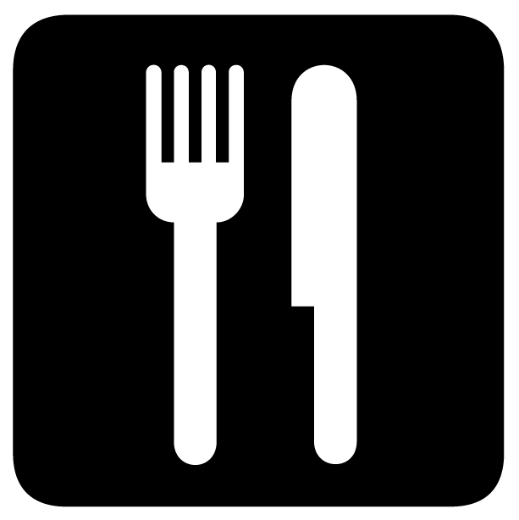
- You go to a restaurant for dinner. You sit down, look at the menu, and realize you left you wallet at home! Luckily, you find $16 in the pocket of your jacket. How much can you spend on the meal before tax and tip?

- At a restaurant you only have $30 to spend on dinner. In addition to the cost of the meal you must pay a 8% sales tax and leave a 20% tip. What is the most expensive item you can order?

