Quiz Corrections Name: __________________________________

A. B. C. D.

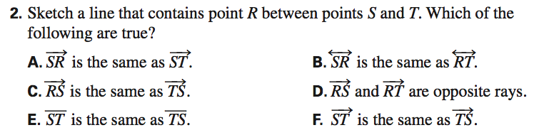

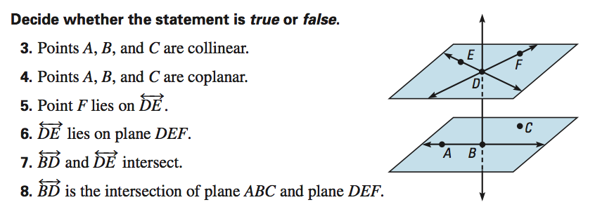

ACT Test Prep

9.
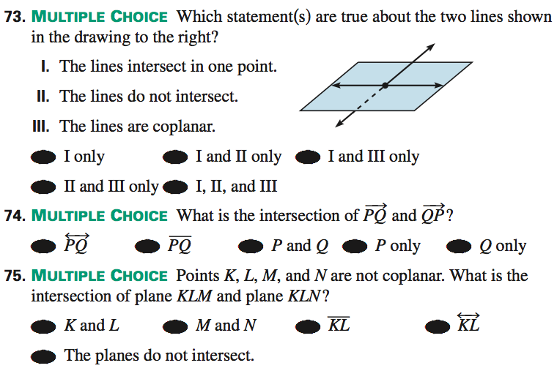

10.

11.

