**Prerequisite Skills** Name: _______________________________________

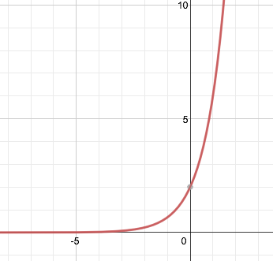

**Vocabulary Check**

1. The asymptote of the graph at the right is ________________________.
2. Two variables x and y show direct variation provided

______________________________ where *a* is a nonzero constant.

1. An extraneous solution of a transformed equation is not an actual ______________________________ of the original equation.



**Skills Check**

**Factor the polynomial completely.**

1. 5.  6. 



**Perform the indicated operation.**

1.  8.  9. 

**Find the least common multiple (LCM) of the numbers.**

1.  11.  12. 

