Section 1 - Functions vs. Relations Notes Name: ____________________
(Vertical Line Test)

Define the following terms:

Relation –

Function –

Domain –

Range –

What is the difference between a relation and function? Provide examples.

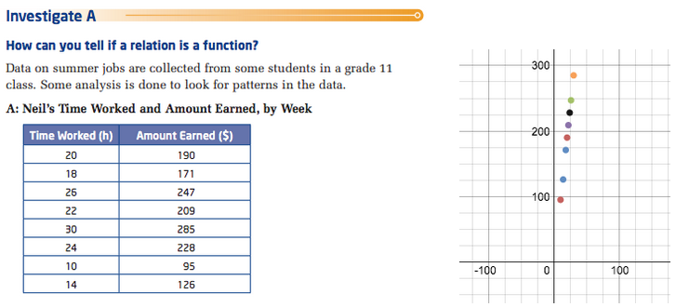

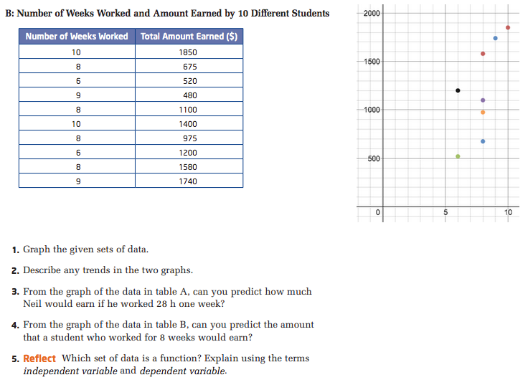
✓  Already completed

Define the following term:

Vertical Line Test –

Watch the video on the vertical line test and determine whether or not each function below represents a function.

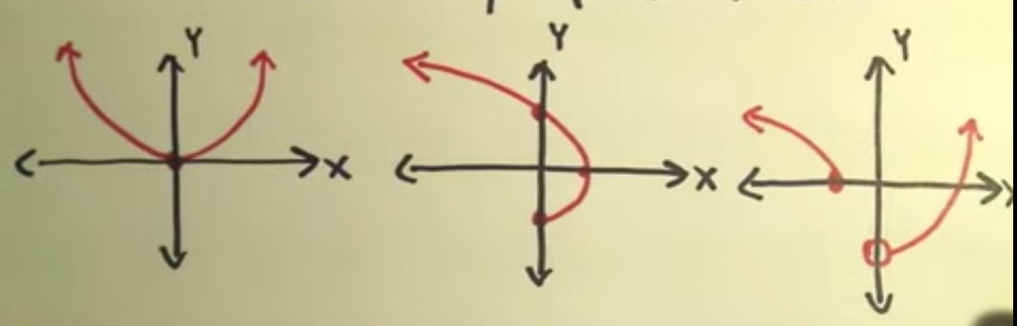

Answer the following questions below, A-D.
a) ____________ b) _______________ c) ________________ d) __________________

Fill in the Blank

If you can ________________________________________________, then it’s a function. In other

words if you can _________________________________________________________________

_______________________________________, then it’s a function.

Solve for y:

