Section 2 - Domain and Range Notes Name: ____________________

(Interval Notation)

Define the following terms:

Domain –

Range –

Find the Domain and Range of the set of points in the table below by watching the Khan Video.

Domain:

Range:

Find the domain and range of the graphs below in interval notation by watching the YouTube video.

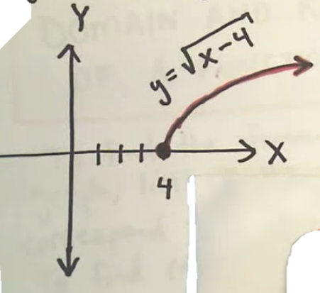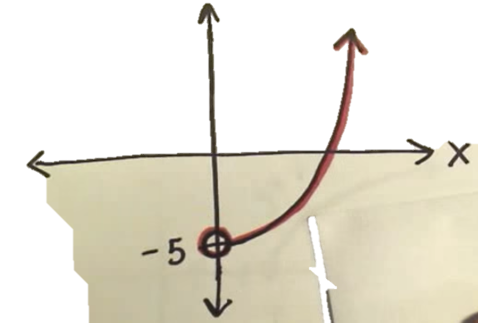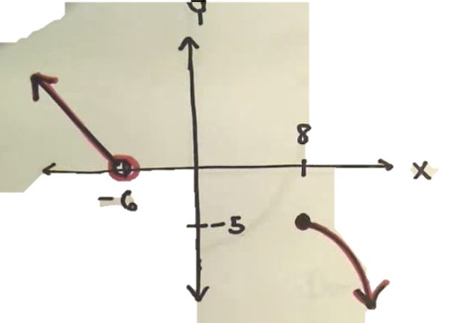

Define the following term:

Restricted Domain –

What are the two different types of restrictions on a domain? Explain each.

- _________________________________________

- _________________________________________

Watch the video and take notes - When is the domain of a function not all real numbers?

Four-Step Process to find a domain

- Assume its all real numbers…unless you see…

- The denominator of a rational function can equal zero.

- There is an even root (usually a square root)

- The problem is an application problem and it has a restricted domain given or stated.

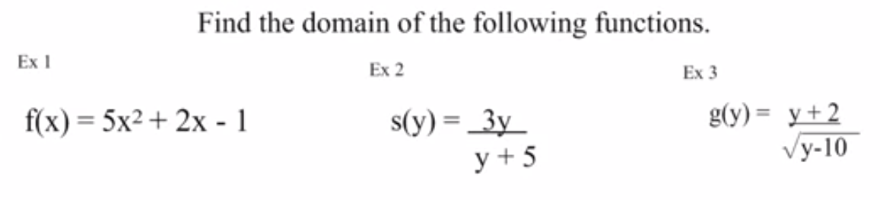

Extra Worked Out Examples

This section also deals with ranges of functions and relations. While domain is the set of inputs of a function, range is the set of outputs. Both are important to mention when describing a graph or function.
Range -
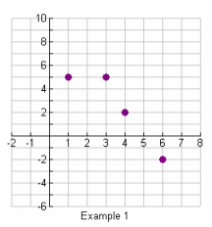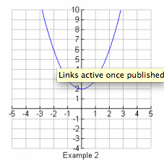

Domain: Domain:

Range: Range:

