Name: ____________________________________

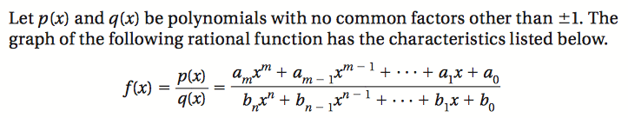

How to find x-intercepts of a rational function:

How to find vertical asymptotes of a rational function:

How to find horizontal asymptotes of a rational function:

How to find “slant” asymptotes of a rational function:

