Section 4 - Interior and Exterior Angles of Polygons Name: ______________________________

Vocab:

**Interior Angles Exterior Angles**

Determine the Sum of Interior Angles

|  |  |  |  |
| --- | --- | --- | --- |
| **Polygon** | **# of Sides** | **# of Triangles Formed** | **Interior Angle Sum of Polygons** |
| Triangle |  |  |  |
| Quadrilateral |  |  |  |
| Pentagon |  |  |  |
| Hexagon |  |  |  |
| Heptagon |  |  |  |
| Octagon |  |  |  |

Now, look at the results in your table. Do you notice a pattern?  Write a rule for finding the sum of the measures of the interior angles of a polygon with n sides.

_____________________________________________________________________

Ex. 1

1. Find the sum of the measures of the interior angles.
2. Find the measure of ONE interior angle

Ex. 2

Find x.



Ex. 3

The sum of the interior angles of a polygon is 720. Find the number of sides.

Ex. 4:

If the sum of the interior angles of a n-gon is 2520 degrees, how many sides does the polygon have?

**Walk the Line**

Determine the Sum of Exterior Angles of a Polygon

_____________________________________________________________________

Ex. 5

Find the measure of ONE exterior angle of a regular hexagon.

Ex. 6

Find the measure of ONE exterior angle of a regular heptagon.

Ex. 7

The measure of the exterior angle of a quadrilateral are x, 3x, 5x, and 3x. Find the measure of each angle.

Ex. 8 Ex. 9

Find x. Find x.

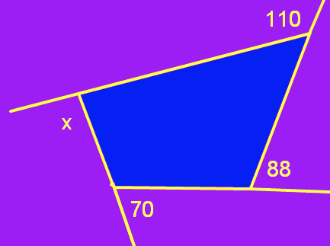 

Ex. 10

Find x.

