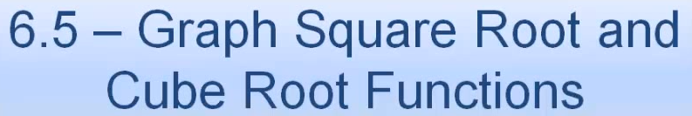 Name: _______________________________________





