 Name: _______________________________________





Macintosh HD:Users:mollyurquhart:Desktop:Screen Shot 2014-02-12 at 8.13.09 AM.png

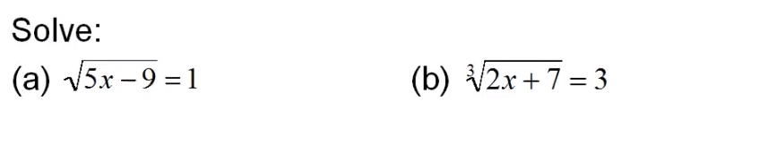







Macintosh HD:Users:mollyurquhart:Desktop:Screen Shot 2014-02-12 at 8.14.32 AM.png







Macintosh HD:Users:mollyurquhart:Desktop:Screen Shot 2014-02-12 at 8.16.26 AM.png