**Solve 2 Step Equations**  Name: __________________________________________

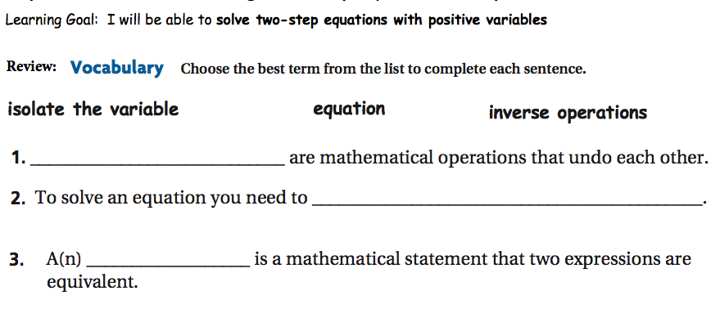

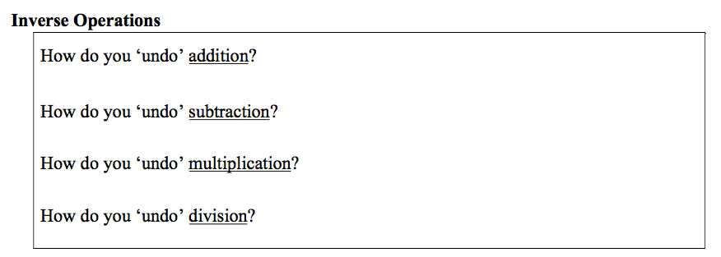

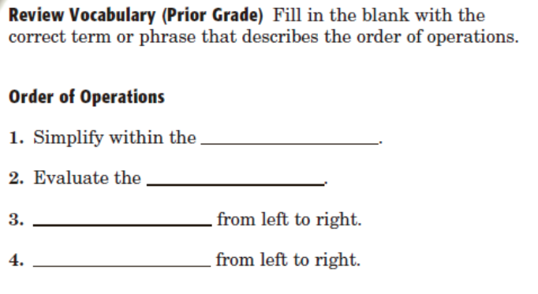

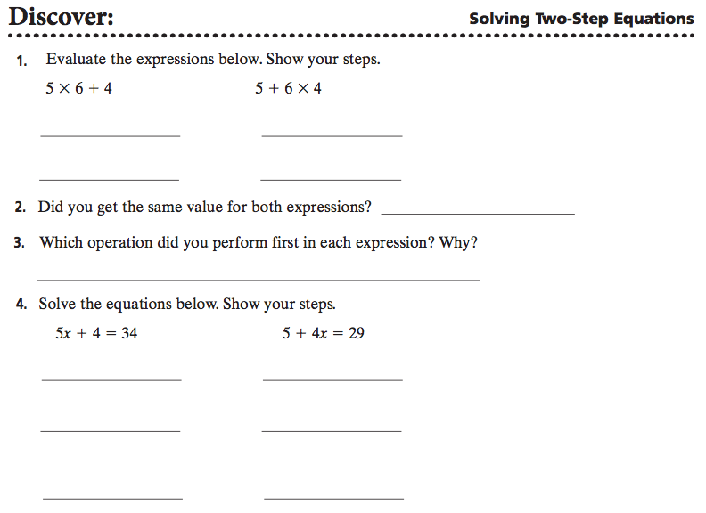

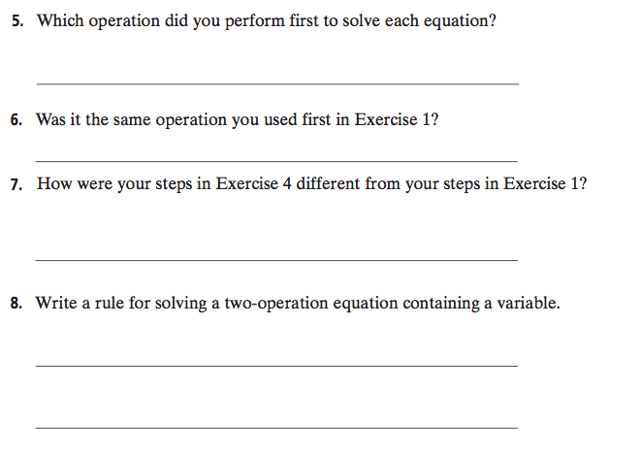

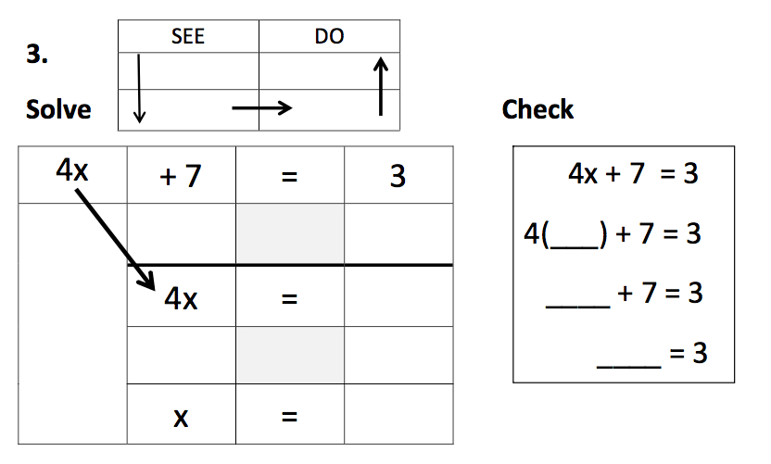

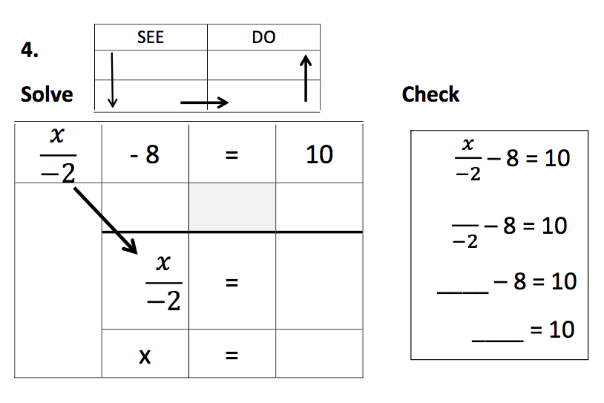

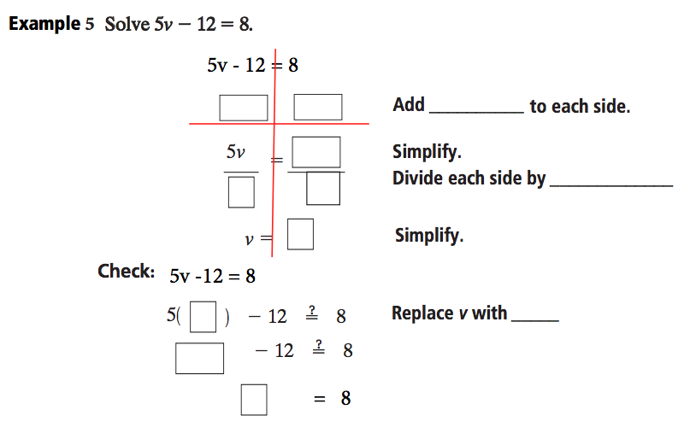

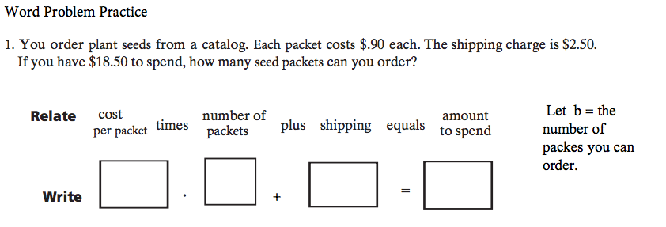

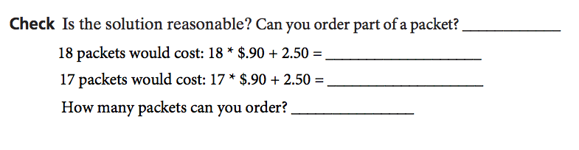

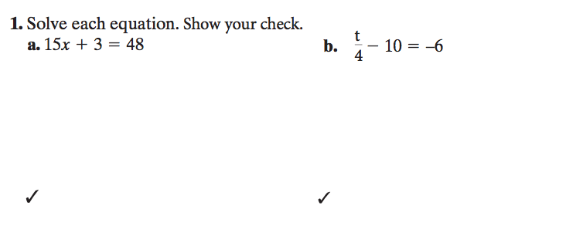

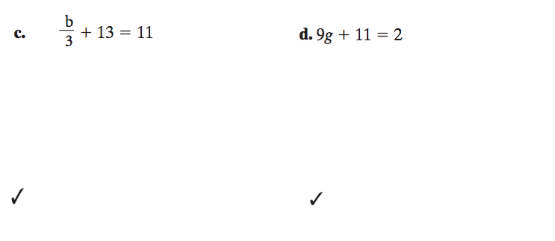

**Two-Step Equations**

Notes:

Solve each equation.

|  |  |  |  |  |  |
| --- | --- | --- | --- | --- | --- |
| 1. |  | 2. |  | 3. |  |
| 4. |  | 5. |  | 6. |  |
| 7. |  | 8. |  | 9. |  |
| 10. |  | 11. |  | 12. |  |
| 13. |  | 14. |  | 15. |  |
| 16. |  | 17. |  | 18. |  |
| 19. |  | 20. |  | 21. |  |

Solve each equation. Check by plugging in your answer.

|  |  |  |  |
| --- | --- | --- | --- |
| 1. |  | 2. |  |
| 3. |  | 4. |  |
| 5. |  | 6. |  |
| 7. |  | 8. |  |
| 9. |  | 10. |  |
| 11. |  | 12. |  |

**Choose the correct equation. Then solve the equation.**

**Sales** A sales representative earns weekly base salary of $250 and a commission of 8% on her weekly sales.(A commission is money earned that equals a percent of the sales.) At the end of one week, she earned $410.How much did she sell that week? Let *s* represent the total sales.

**A.** 250 + 0.08*s* = 410 **B.** 250 + 410 = 0.08*s*

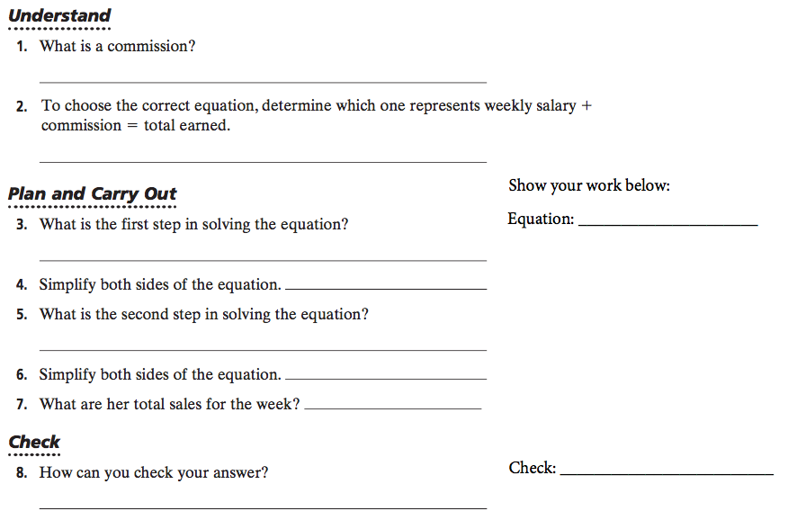

**Solve Another Problem**

**9.** A sales representative earns pay as described above. During a holiday promotion, he earned $650. What were his total sales for that week?

