Solving Proportions Name: _____________________________

**Proportion** says that two ratios (or fractions) are equal.

How do we solve proportions?

With cross multiplication, which states

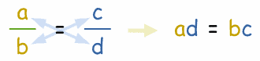

Cross Multiplication

Why does cross multiplication work?

Because…. if we multiply both sides by the product of the denominators. The numbers will naturally cancel.



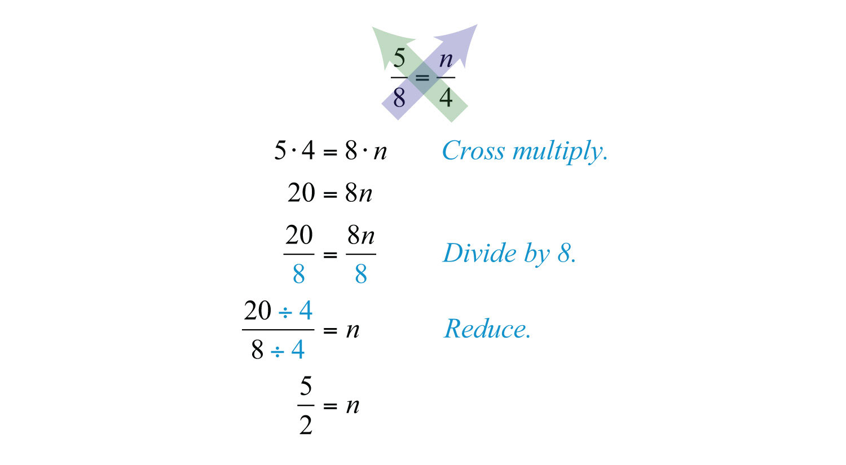

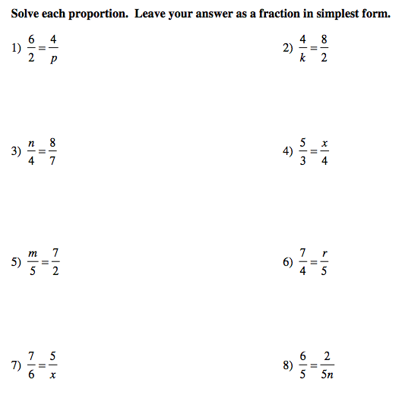



Setting up and Using Proportions in Geometry.

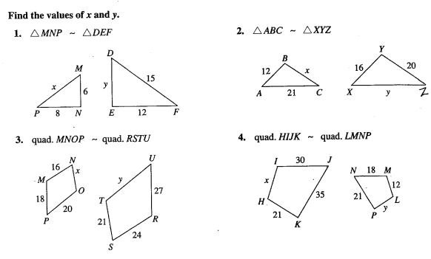

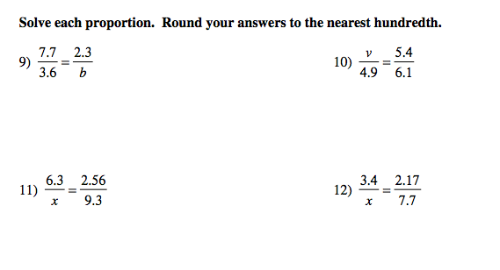

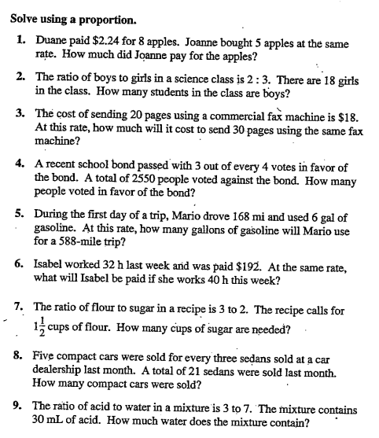

10. How many liters are in the first bottle?

