SPECIAL RIGHT TRIANGLES NAME: ______________________________

**Find the equation for the length of diagonal though any square.**



**Find the equation for the lenth of the altitude of any equilateral triangle.**

Summarizing the pattern:

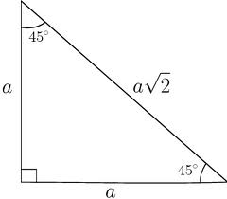 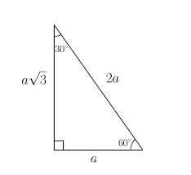

Examples

1. 2.

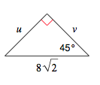 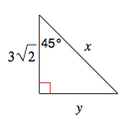

3. 4.

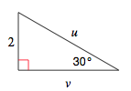 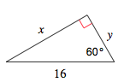

5. 6.

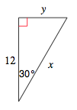 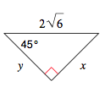

7. 8.

 