Three Forms of Name: _______________________________________

the Quadratic Equation

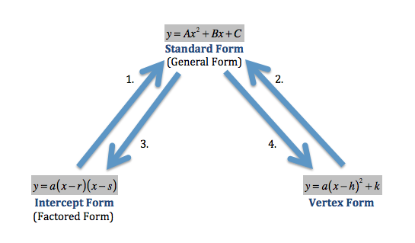

1. Intercept Form to Standard Form
2.  B. 
3. Vertex Form to Standard Form

A.  B. 

1. Standard Form to Intercept Form

A.  B. 

C.  D. 

E.  F. 

1. Standard Form to Vertex From

A. 

B. 

C. 