Trigonometric Functions Name: ________________________________
SECTION 1

Goal: Students should be able to evaluate the six trigonometric ratios of a right triangle

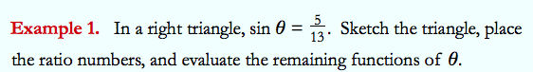
Problem 1

Problem 2
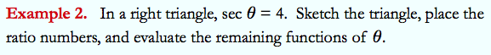

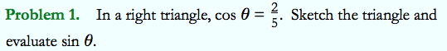
Problem 3

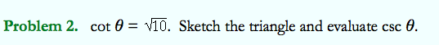
Problem 4

Problem 6
Problem 5

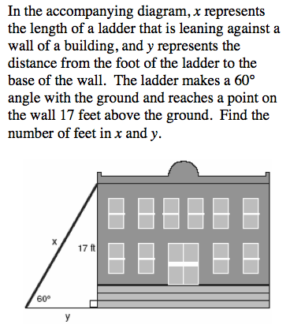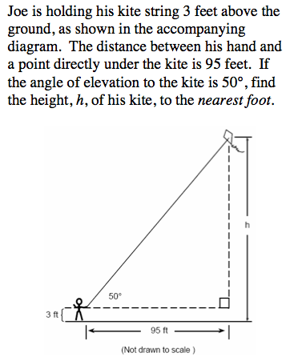

Problem 7

