Trigonometric Functions Name: ________________________________
SECTION 2 - Missing Angles and Reference Angles

Goal: Students should be able to find a missing angle given two sides of any right triangle.

Problem 1

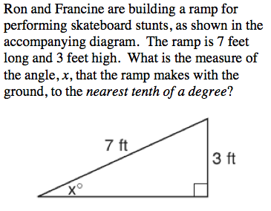

Problem 2

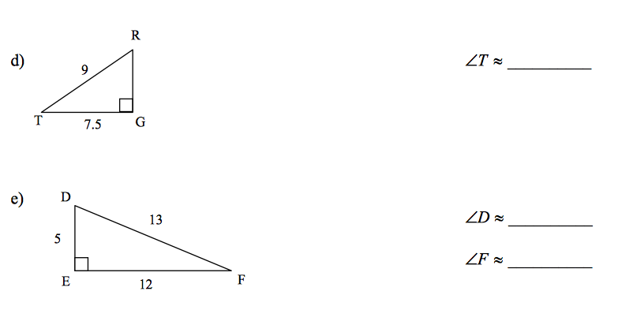

Problem 2

