Trigonometric Functions Name: ________________________________

SECTION 2 - Missing Angles and Reference Angles

**Goal:** *Students, without a calculator, should be able to find a missing angle of any special right triangle.*

**Problem Set 1**

Without a calculator find the missing angle.

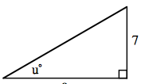 (1) (2) (3)

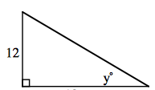 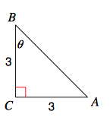

24

14

**Problem Set 2**

Without a calculator find the missing angle. (Hint draw the triangle out)

(4)  (5)  (6) 

(7)  (8)  (9) 