Unit 2 Project/Presentation Name ____________________________________ Date _______
Group B
_______ out of 42 points

Fill in boxes.
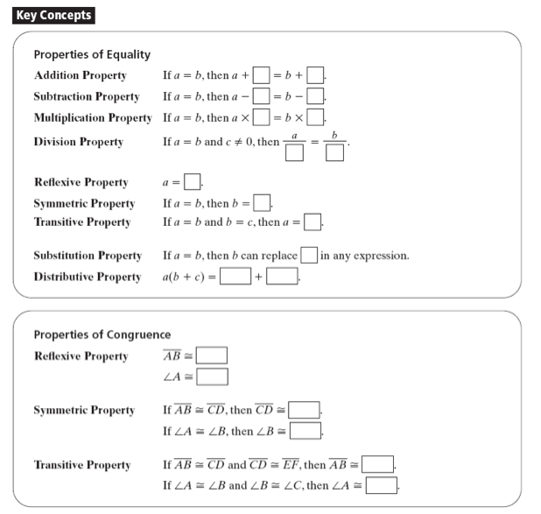

Use these properties to justify each step of an algebraic proof. For the most part, algebraic proof looks like solving equations! But to make it a proof, organize into two columns: statements and reasons.

ALGEBRAIC PROOFS

- (5 points)

Statements | Reasons

2. (5 points)

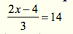

Statements | Reasons
GEOMETRIC PROOFS

3. (6 points)

Statements | Reasons

4. (6 points)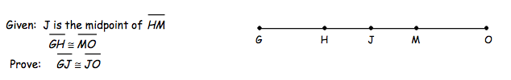

Statements | Reasons
5. (8 points)

Statements | Reasons

