Unit 6 Review for Test Name: ______________________________________

Geometry - Right Triangles

Main Ideas for Unit 6

Section 1 - Pythagorean Theorem

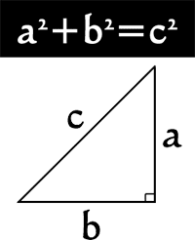 If you have a right triangle, then the hypotenuse squared is equal to the sum of the square of the two legs of the triangle.

Section 2 - Distance Formula



Section 3 - Converse to the Pythagorean Theorem

 If the longest side squared is equal to the sum of the square of the two shorter sides of the triangle, if you have a right triangle.

Section 4 - Special Right Triangles

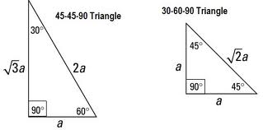

Section 5 - Trigonometry (Sine, Cosine, and Tangent)

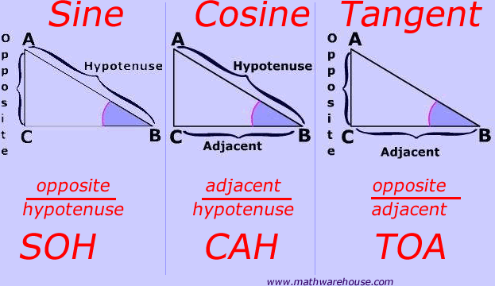

Section 6 - Area of Regular Polygons

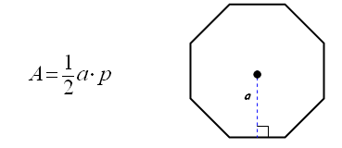

Practice Problems for Unit 6

**Use the properties of special right triangles (30°-60°-90° and 45°-45°-90°) to solve problems**

1) If , then the exact value of  is…

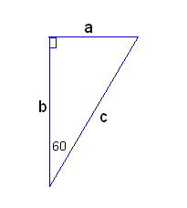a)  b)  c)  d) 

2) If , then the exact value of  is…

a)  b)  c)  d) 

3) If, then the value of  to the nearest tenth is…

a)  b)  c)  d) 

4) If, then the value of  to the nearest tenth is…

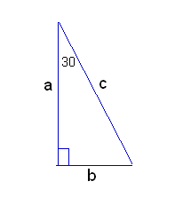a)  b)  c)  d) 

5) If, then the value of  to the nearest tenth is…

a)  b)  c)  d) 

6) If , then the value of  to the nearest tenth is…

a)  b)  c)  d) 

7) If, then the value of  to the nearest tenth is…

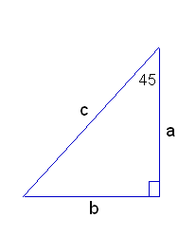a)  b)  c)  d) 

8) If, then the value of  to the nearest tenth is…

a)  b)  c)  d) 

9) If , then the exact value of  is…

a)  b)  c)  d) 

10) If, then the exact value of  is…

a)  b)  c)  d) 

**The following practice problems use special right triangles to work with involve geometric shapes. With some of these you could also use the Pythagorean Theorem**

|  |  |  |
| --- | --- | --- |
| 11) What is the exact side length of a square that has a  diagonal length of 12 inches? | 12) What is the exact perimeter of an equilateral  triangle that has a height of 18 cm? | |
| 13) Which expression gives the correct length for *x* + *y* in the diagram below?  A.  B.  C.  D.  E. | | 45°  *x*  400 ft  *y*  30° |
| 14) If segment AB has a length of 20, what is the exact radius of the circle with center O? | | [image] |
| 15) The head of a bolt is in the shape of a regular hexagon with each side 80 mm in length. What is the exact distance between opposite vertices of the bolt? | | [image] |
| 16) Find the exact area of the regular octagon if the inscribed circle has a radius of 10. | 17) Find the exact area of the regular hexagon if the circumscribed circle has a radius of 8. | |
| [image] | [image] | |

**Practice solving problems using special right triangles that involve reading a problem and visualizing or drawing a picture.**

1. A right triangle has a 60 degree angle, and the leg adjacent to that angle has a length of 7 in. Find the length of the other leg.
2. A right triangle has a 45 degree angle, and the hypotenuse has a length of 8 ft. Find the length of a leg.
3. The hypotenuse of a right triangle with a 30 degree angle has a length of 9 cm. What is the length of the leg adjacent to the 30 degree angle?
4. The diagonal of a square has a length of 18 cm. Find the area of the square.
5. The height of an equilateral triangle is 6 in. Find the perimeter of the triangle.
6. 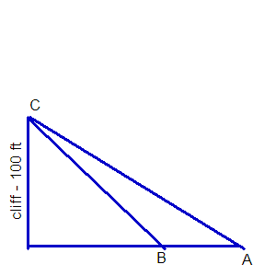Albert is standing at point A. He takes a sighting to the top of a cliff, (point C). The angle of elevation is 30 degrees. Becky is standing at point B and takes a sighting to the top of the same cliff, (point C). The angle of elevation is 45 degrees. If the cliff is 100 feet high, find the exact distance between Albert and Becky.

1. 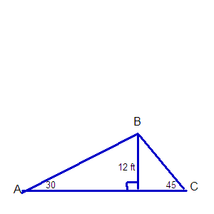A roof is short and steep on one side, and longer and more gradual on the other side. (See diagram shown)
2. Calculate the number of linear feet of roofing required, (from A to B to C).
3. Find the length of the longest building the roof would cover, (from point A to point C).

Still need more practice? Try these additional problems using Special Right Triangles

1. Determine the length of the altitude of an equilateral triangle whose side lengths measure 5 units. (Adapted from OSPI Geometry Crosswalk)

2. If one leg of a right triangle has length 5 and the adjacent angle is 30°, what is the length of the other leg and the hypotenuse?

3. If one leg of a 45°–45°–90° triangle has length 5, what is the length of the hypotenuse?

4. The pitch of a symmetrical roof on a house 40 feet wide is 30º. What is the length of the rafter, *r*, exactly and approximately.

**Application problems with right triangles**

5. A juice box has a base of 6 cm by 8 cm and a height of 12 cm. A straw is inserted into a hole in the center of the top. The straw must stick out 2 cm so you can drink from it. If the straw must be long enough to touch each bottom corner of the box, what is the minimum length the straw must be? (Assume the diameter of the straw is 0 for the mathematical model.) Include a sketch of the juice box labeling the dimensions. (Adapted from OSPI Geometry Crosswalk)

6. A rectangular prism is shown. The base of the prism is a square. The length of the diagonal from top corner A to opposite bottom corner B is 2 feet. Determine the exact length of the box in inches. (Adapted from OSPI Mathematics Assessment Updates for 2011: End-of-Course High School Proficiency Exams)

7. Determine whether a triangle with the following coordinates is acute, right or obtuse using the Distance Formula

and the inverse of the Pythagorean Theorem.

A (-2, 1), B(2, 5) and C(9, -3)

**Using sine, cosine and tangent ratios to solve problems**

**Solve problems involving the basic trigonometric ratios of sine, cosine, and tangent.**

8. A 12-foot ladder leans against a wall to form a 63° angle with the ground. How many feet above the ground is the point on the wall at which the ladder is resting? Include a sketch of the situation. (Adapted from OSPI Geometry Crosswalk)

9. A 13-foot ladder is leaning against a brick wall. The top of the ladder touches the wall 12 feet (ft) above the ground. (a) What is the angle formed by the ground and the base of the ladder? (b) How far is the base of the ladder from the wall? Include a sketch of the situation. (Adapted from California Standards Tests)

10. Triangle ABC has a right angle at C. Angle A measure 32 degrees and side AC measures 10 inches. What is the height of triangle ABC? Include a sketch of the situation.

1. Billy is standing on the top of a backyard swing set slide. As he looks back, he notices that the angle of depression for the 8 foot ladder foot is 57 degrees. How high off the ground is Billy? Make a sketch of the situation.
2. Sally has measured the shadow cast by the blue spruce tree in her family’s front yard to be about 64.25 feet. She estimates that the angle of elevation when she is standing at the end of the shadow to the top of the blue spruce is 50 degrees. Determine (a) the height of the tree and (b) the distance Sally is from the top of the tree. Make a sketch of the situation.



1. Triangle ABC is shown below.

Which equation should be used to find the length of segment AC if angle C is a right angle?

a.  b. 

c.  d. 

14. In the triangle below, if , find the .

A

b c

C a B

1. In the triangle above, if BC = 21 and sin A = 0.7, what is the length of AB?

A. 14.7 B. 21.7 C. 30 D. 32

16. Find *x* + *y* to the nearest tenth.

*x*

16 m

58°

*y*

A. 5.0 m

B. 10.0 m

C. 18.9 m

D. 28.9 m

E. 30.2 m

35˚

200 ft

17.

[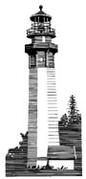](http://www2.free-clipart.net/cgi-bin/clipart/directory.cgi?action=view&link=clipart/Landscapes&image=Lighthouse_1.jpg&img=24)

42

300ft Approximately how tall is the lighthouse if the angle of elevation

shown is 42 degrees?

A

8.7 10.2

C B

43˚

18.

Which equation gives the correct value for BC?

A. sin 43˚ =  B. cos 43˚ =  C. tan 47˚ =  D. sin 47˚ = 

Using right triangles to determine “Areas” and a couple other problems

1. If is a rhombus, what is the area of ?



A.  sq units B.  sq units C.  sq units D.  sq units

2. What is the area of the triangle below?



A.   B.   C.   D.  

3. What is the area of rhombus RSTV, if  cm and cm?



A. 136  B. 272  C. 60  D. 240 

**4.** In the figure below, and *BC* = 10 units. What is the area, in square inches, of Δ*ABC*?

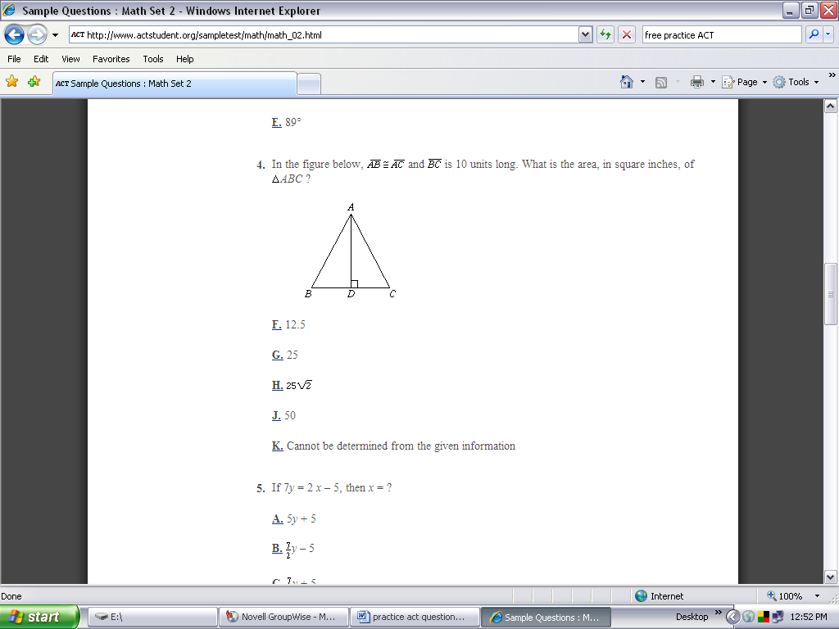

A. 12.5

B. 25

C. 

D. 50

E. Cannot be determined from the given information

**A few more problems**

1. In a right triangle, the length of one leg is 9 in and the length of the other leg is 6 in. What is the length of the hypotenuse?

1. 3 in
2. 15 in
3. 
4. 

2. The length of a diagonal of a square is 10 inches. What is the perimeter of the square?

A. in

10 in

B. in

C. in

D. in

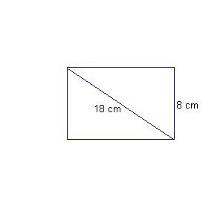 E. 50 in

3. What is the length of this rectangle?

1. 10 cm
2. cm
3. cm
4. 26 cm

3. The right triangle below has an area of 384 in2. Find the perimeter.

A. 12 in

32 in

B. 24 in

C. 40 in

D. 84 in

E. 96 in

4. The diagram shows. Which statement would prove that is a right triangle?

1. the distance from D to F = distance from D to E
2. 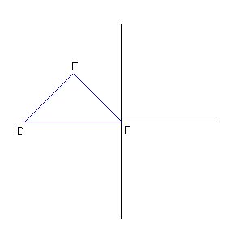the distance from D to E = distance from F to E
3. slope of *slope of  = 1
4. slope of *slope of  = -1

5.

